**Requirements Analysis, and Design**

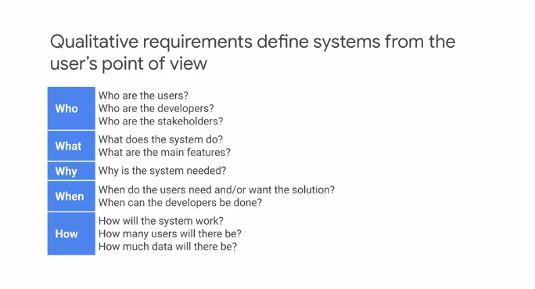

Let's start talking about requirements, analysis, and design. Useful questions to ask a Cloud architect to help build the requirements are who, what, why, when, and how. The who is about determining not only the user of the system, but also the developers and stake holders. The aim is to build a full picture of who the system will affect both directly and indirectly. The what is both simple and difficult, we need to establish the main areas of functionality required, but in a clear, unambiguous manner. Why the system is needed, is a really important question. What is a problem the proposed system aims to address or solve? Without a clear understanding of the need, it is likely that extra requirements will be added. The why will also potentially help in defining KPIs, and SLOs, and SLAs. When, helps determine a realistic timeline and can help contain the scope. How, helps to determine a lot of the non-functional requirements. These could be, for instance, how many users the system needs to support concurrently? What does the average payload size of service requests? Are there latency requirements, etc? They could be that the users will be located across the world or in a particular region only. All of these requirements are vital to capture, because they impact the potential solution you as a Cloud architect will provide. In the previous design activity, you defined user roles for your application. Roles represent the goal of a user at some point and they enable the analysis of a requirement in a particular context. It is important to note that a role is not necessarily a person, it is an actor on the system and it could be another system such as a microservice client that is accessing another microservice. The role should describe the user's objective when using the system. For example, the role of a shopper on an eCommerce application clearly defines what the user wants to do. There are many ways to determine the roles for the requirement you working on. One process that works particularly well is, first brainstorm an initial set of roles. Write as many roles as you can think of, with each role being a single user. Now, organize this initial set. Here, you can identify overlapping roles and related roles, and group these together. With the set of roles now grouped, consolidate the roles, the aim here is to consolidate and condense the roles to remove duplication. Finally, refine the roles including internal and external roles, and the different usage patterns. Here, extra information can be provided, such as the user's level of expertise in the domain or the frequency of use of the proposed software. Following a simple process like this, provide structure and brings focus to the task. Identifying user roles is a useful technique that's part of the requirements getting process. An additional technique, in particular for more important roles can be to create a persona for the role. A persona is an imaginary representations of a user role. The aim of the persona is to help the architect and developers think about the characteristics of users by personalizing them. Often, a role has multiple personas. Consider the example of requirements for a banking application. We can think in terms of users of the system and many requirements can be gathered this way. Using personas can provide further insights. For example, Jocelyn is a person who's a busy working mom. Jocelyn wants to save time and money as well as perform these standard banking operations online and receive benefits such as cashback. Using a persona helps build a fuller picture of the requirements. For instance, Jocelyn's wanting to save time indicates that the task to be performed should possibly be automated, which affects latency hence service design. In this example, when a question rises from the architect or maybe a developer, they can often better answer that question by thinking, what would Jocelyn want here? Now, user stories describe one thing a user wants the system to do, they are written in a structured way typically using the form as a, type of user, I want to do something so that I can get some benefit. Another commonly used form is given some context, when I do something, then this should happen. So when writing stories, give each story a title that describes its purpose as a starting point, follow this with a concise, one-sentence description of the story that follows one of the forms just described. This form describes the user role, what they want to do and why they want to do it. As an example, consider a banking system and a story to determine the available balance of a bank account. The title of the story could be balance inquiry. Then following the template we described the story as an account holder, I want to check my available balance at any time of day, so I am sure not to overdraw my account. This explains the role, what they want to do and why they want to do it.

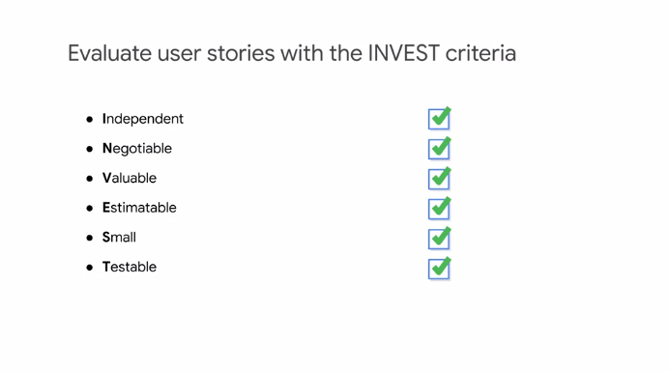

User stories provide a clear and simple way of agreeing to requirements with a customer/end-user. The invest criteria can be used to evaluate good user stories. Let me go through each letter of these criteria. Independent, a story should be independent to prevent problems with prioritization and planning. Negotiable, they are not written contracts, but are used to stimulate discussion between customer and developers until there is a clear agreement, they add collaboration. Valuable, story should provide value to users. Think about outcomes and impact, not outputs and deliverables. Estimatable, the story must be estimatable. If it is not, it often indicates missing details or the story is too large. Small, good stories should be small, this helps keep scope small and therefore less ambiguous and supports fast feedback from users. Testable, stories must be testable so that developers can verify that the story has been implemented correctly and validate when requirement has been met slash/is done.

**KPIs and SLIs**

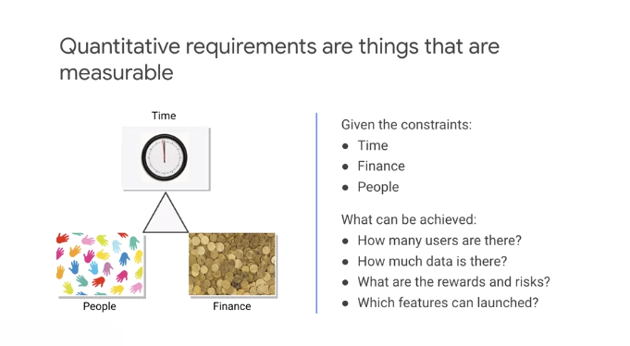**月**

With a set of requirements in place, we will now move on to consider how to measure whether the technical and business requirements have been met. To manage a service well it is important to understand which behaviors matter and how to measure and evaluate these behaviors. These must always be considered in the context of the constraints which are usually time, funding, and people. Then we consider what can be achieved. The type of system being evaluated determines the data that can be measured, for example, for user-facing systems was a request responded to which refers to availability. How long did it take to respond, which refers to latency. How many requests can be handled, which refers to throughput. For data storage systems, how long does it take to read and write data? That's latency. Is the data there when we need it, that's availability. If there is a failure to we lose any data, that's durability.

The key to all of these items is it the questions can be answered with data gathered from the services.

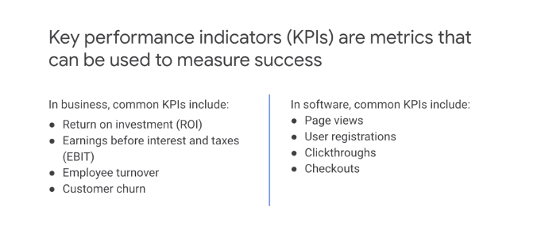

Business decision makers want to measure the value of projects. This enables them to better support the most valuable projects and not waste resources on those that are not beneficial. A common way to measure success is to use KPIs, KPIs can be categorized as Business KPIs and Technical KPIs.

Business KPIs are a formal way of measuring what the business values such as ROI in relation to a project or service. Others include, earnings before interest and taxes or impact on users, such as customer churn or maybe employer turnover.

Technical or software KPIs can consider aspects such as how effective the software is through page views, user registration, and number of checkouts. These KPIs should also be closely aligned with business objectives. As an architect, it is important that you understand how the business measures success of the systems that you design.

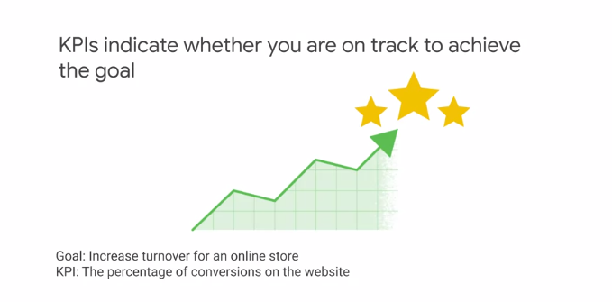

Now, a KPI is not the same thing as a goal or objective. The goal is the outcome or result you want to achieve, the KPI is a metric that indicates whether you are on track to achieve the goal. To be the most effective, KPIs need an accompanying goal. This should be the starting point in defining KPIs, then for each goal define the KPIs that will allow you to monitor and measure progress. For each KPI, define targets for what success looks like. Monitoring KPIs against goals is important to achieving success and allows readjustment based on feedback. As an example, a goal may be to increase turnover for an online store and an associated KPI maybe the percentage of conversions on the website. For KPIs to be effective, they must be specific rather than general. For example, user friendly is not specific, it's very subjective. Section 508 Accessible is much more specific. Measurable is vital because monitoring the KPIs indicates whether you're moving toward or away from your goal. Being achievable is also important, for example, expecting 100% conversions on a website is not achievable. Relevant is absolutely vital, without a relevant KPI the goal probably will not be met. In our example of increasing turnover, we're improving the conversion rate as subsequent increase in turnover should be achievable assuming a similar number of users. Time-bound helps with measuring the KPI. Some KPIs are more sensitive to time, for example, is availability per day, per month or per year.

So to summarize, KPIs are used to measure success or progress toward a goal.

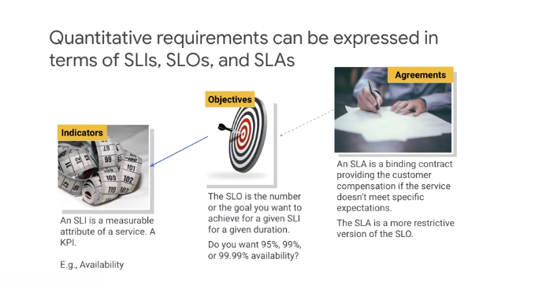

Let's introduce service level terminology. To provide a given level of service to customers, it is important to define service level indicators or SLIs, objectives or SLOs and agreements or SLAs. These are measurements that describe basic properties of the metrics to measure. The values those metrics should read and how to react if the metrics cannot be met. Service level indicator is a quantitative measure of some aspect of the level of service being provided. Examples include throughput, latency, and error rate.

Start transcript at 4 minutes 31 seconds4:31

Service level objective is an agreed upon target or range of values for a service level that is measured by an SLI.

Start transcript at 4 minutes 39 seconds4:39

It is normally stated in the form of SLI is smaller than equal to target or lower bound, which is smaller than, equal to SLI, smaller than, equal to upper bound. An example of an SLO is that an average latency of HTTP requests for our service should be less than 100 milliseconds. Service level agreement is an agreement between a service provider and a consumer. They define responsibilities for delivering a service and consequences when these responsibilities are not met. The SLA is a more restrictive version of the SLO. We want to architect a solution and maintain an agreed SLO, so that we provide ourselves spare capacity against the SLA. Understanding what users want from a service will help inform the selection of indicators.

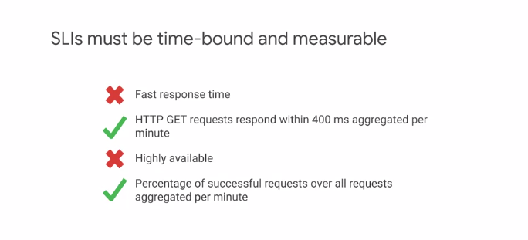

The indicators must be measurable, for example, fast response time is not measurable. Whereas HTTP GET requests that respond within 400 milliseconds aggregated per minute is clearly measurable. Similarly, highly available is not measurable but percentage of successful requests over all request aggregated per minute is measurable. Not only must indicators be measurable but the way they are aggregated needs careful consideration.

For example, consider requests per second to a service, how is the value calculated? By measurements obtained once per second or by averaging request over a minute? The once per second measurement may hide high requests rates that occur in bursts of a few seconds. For example, consider a service that receives 1,000 requests per second on even-numbered seconds and 0 requests on odd-numbered seconds. The average requests per second could be reported over a minute as 500. However, the reality is that the load at times is twice as large as the average. Similar averages can mask user experience when used for metrics like latency. It can mask the request the take a lot longer to respond than the average. It is better to use percentiles for such metrics, where a high order percentile, such as 99% shows worst-case values. While the 50th percentile would indicate a typical case.

**SLOs and SLAs**

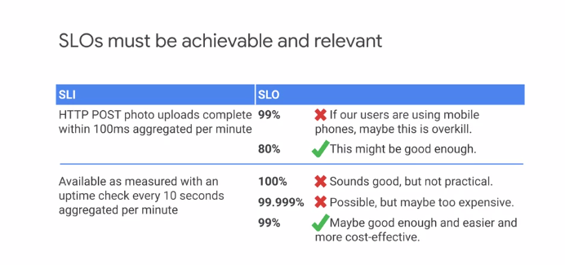

The relevancy of SLOs is vital. You want objectives that help or improve the user experience.

It is easy to define a SLOs based around what is easy to measure rather than what is useful. For clarity, SLOs should specify how they are measured and the conditions when they are valid. Consider availability as measured with an uptime check over ten seconds aggregated per minute. It is unrealistic as well as undesirable to have SLOs with a 100% target. Such a target results in expensive, overly conservative solutions, that are still unlikely to reach the SLO. It is better to track the rate at which SLOs are missed and work to improve this. In many cases 99% may be good enough availability and be far easier to achieve as well as engineer. It is also highly likely to be much more cost-effective to run. The use case needs to be considered also. For example, if a HTTP service for photo uploads requires 99% of uploads to be complete within 100 milliseconds aggregated per minute, this may be unrealistic or overkill if the majority of users are using mobile phones. In such a case, an SLO of 80% is much more achievable and good enough. It is often okay to specify multiple SLOs. Consider the following, 99% of HTTP get calls will complete in less than 100 milliseconds. This is a valid SLO, but it may be the case that the shape of the performance curve is important. In this case, the SLO could be written as follows. 90% of HTTP get calls will complete in less than 50 milliseconds, 99% of HTTP get calls will complete in less than 100 milliseconds.

And 99.9% of HTTP get calls will complete and less than 500 milliseconds.

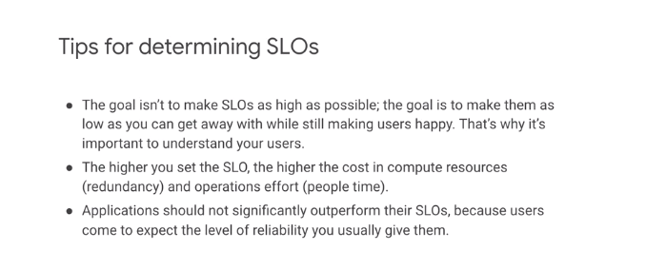

Selecting SLOs has both product and business implications. Often trade-offs need to be made based on constraints such as staff, time to market and funding. As the slide states, the aim is to keep users happy, not to have an SLO that requires heroic efforts to maintain.

Let me give you some tips on selecting SLOs.

Do not make them too high. It is better to have lower SLOs to begin with and tighten them over time as you learn about the system, instead of defining those that are unattainable and require a significant effort and cost try and achieve. Keep them simple. More complex SLOs can obscure important changes in performance.

Avoid absolute values. To have a SLO that states 100% availability is unrealistic. Such an SLO increases the time to build, complexity, and cost to operate. And in most cases is highly unlikely to be required.

Minimize SLOs. A common mistake is to have too many SLOs. The recommendation is to have just enough SLOs to give coverage of the key system attributes. In summary, good SLOs should reflect what the users care about. They work as a forcing function for development teams. A poor SLO will result in a significant amount of wasted work if it is too ambitious or a poor product if it is to relaxed. An SLA is a business contract between the service provider and the customer.

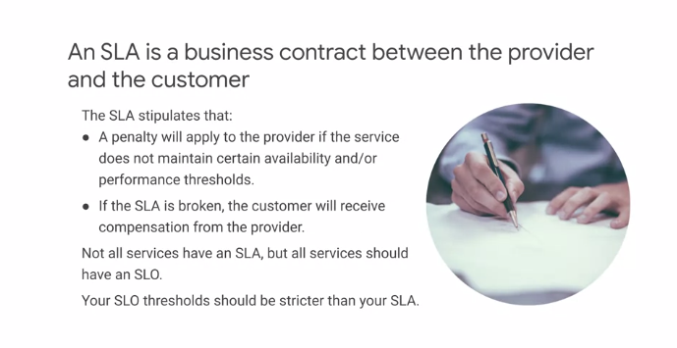

A penalty will apply if the service provider does not maintain the levels agreed on. Not every service has an SLA, but all services should have a SLOs. As with SLO, it is better to be conservative with SLAs because it is too difficult to change or remove SLAs that offer little value or cause a large amount of work. In addition, because they can have a financial implication through compensation to the customer, setting them too high can result in unnecessary compensation being paid. To provide protection and some level of safety, an SLA should have a threshold that is lower than the SLO. This should always be the case.

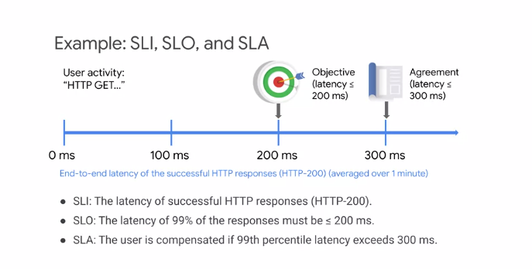

Let's consider an example of a service, An SLI, SLO and SLAs for the service. The service is an HTTP endpoint accessed using HTTP get. The SLI is the end-to-end latency of successful HTTP responses. That is HTTP-200. These are averaged over one minute.

The SLO has been agreed that the latency of 99% of the responses must be less than or equal to 200 milliseconds.

The SLA is set that the user is compensated if the 99th percentile latency exceeds 300 milliseconds. The SLA has clearly built a buffer over the SLO, which means that even if the SLO is exceeded there is some capacity before the SLA is broken. This is the wanted position in the relationship between SLO and SLA.

**Microservices**

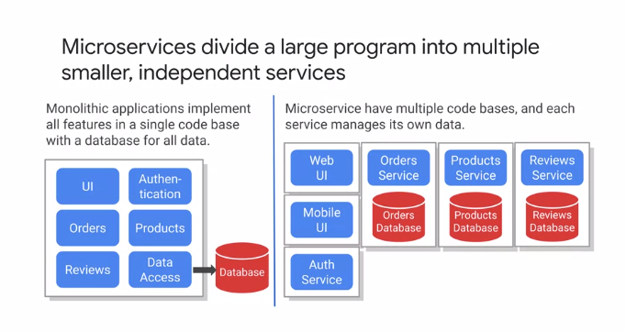

Let's begin by looking at microservices in more details. Microservices divide a large program into a number of smaller independent services as shown on the right, unlike a monolithic application which implements all features in a single code base with the database for all data as shown on the left. Microservices are the current industry trends. However, it's important to ensure that there is a good reason to select this architecture. The primary reason is to enable teams to work independently and deliver through to production at their own cadence. This supports scaling the organization, adding more teams, increases speed. There's also the additional benefit of being able to scale the microservices independently based on their requirements. Architecturally, an application designed as a monolith or around microservices should be composed of modular components with clearly defined boundaries. With the monolith, all the components are packaged at deployment time and deployed together. With microservices, the individual components are deployable. Google Cloud provides several compute services that facilitate deploying microservices. These include App Engine, Cloud Run, GYVE, and Cloud functions. Each offers different level of granularity and control and will be discussed later in the course. To achieve independence on services, each service should have its own datastore. This lets the best datastore solution for that service to be selected and also keeps the services independent. We do not want to introduce coupling between services through a datastore.

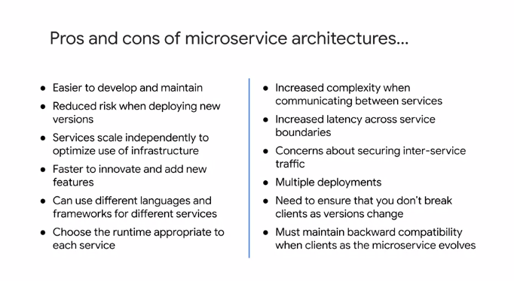

A properly designed microservices architecture can help achieve the following goals. Defined strong contracts between the various microservices, allow for independent deployment cycles including rollback, facilitate concurrent AB release testing on subsystems, minimize test automation and quality assurance overhead, improve clarity of logging and monitoring, provide fine grained cost accounting, increase overall application, scalability, and reliability through scaling smaller units. However, the advantages must be balanced with the challenges this architectural style introduces. Some of these challenges include, it can be difficult to define clear boundaries between services to support independent development and deployment. Increased complexity of infrastructure with distributed services having more points of failure. The increased latency introduced by network services and the need to build in resilience, to handle possible failures, and delays. Due to the networking involved, there is a need to provide security for service to service communication, which increases complexity of infrastructure. Strong requirement to manage in version service interfaces with independent deployable services, the need to maintain backward compatibility increases.

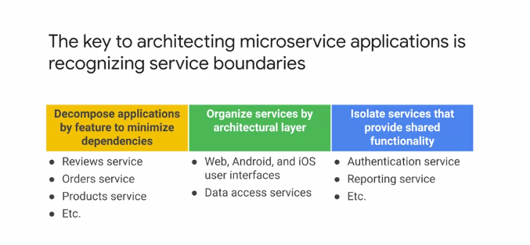

Now, decomposing applications into microservices is one of the biggest technical challenges of application design. Here, techniques like domain-driven design are extremely useful in identifying logical functional groupings. The first step is to decompose the application by feature or functional groupings to minimize dependencies. Consider for example, an online retail application. Logical functional groupings could be product management, reviews, accounts, and orders. These groupings then form mini applications, which expose an API. Each of these mini applications will be implemented by potentially multiple microservices internally. Internally, these microservices are then organized by architectural layer, and each should be independently deployable and scalable. Any analysis will also identify shared services such as authentication, which are then isolated and deployed separately from the mini applications.

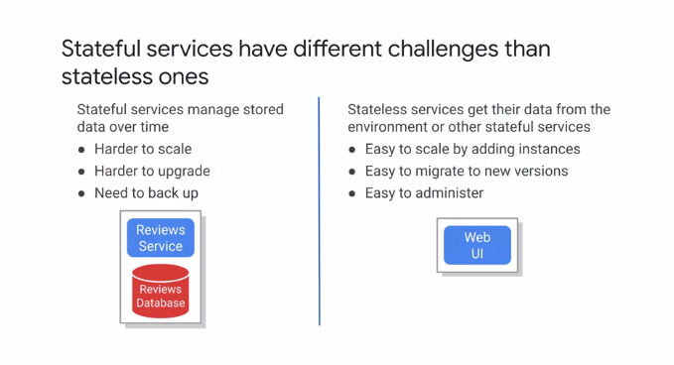

When you are designing microservices, services that do not maintain state but obtain their state from the environment or stateful services are easier to manage. That is, they are easy to scale, to administer, and to migrate to new versions because of their lack of state. However, it is generally not possible to avoid using stateless services at some point in a microservice based application. It is therefore important to understand the implications of having stateful services on the architecture of the system. These include, introducing significant challenges in the ability to scale and upgrade the services. Being aware of how state will be managed is important in the very early stages of microservice application design. Let me introduce some suggestions and best practices on how this can be achieved.

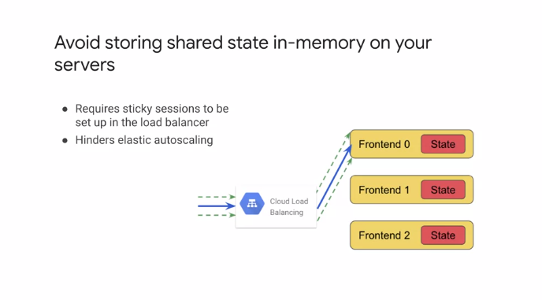

In memory, shared state has implications that impact and negate many of the benefits of a microservice architecture. The autoscaling potential of individual microservices is hindered because subsequent client requests have to be sent to the same server that the initial request was made to. In addition, this requires configuration of the load balancers to use sticky sessions, which in Google Cloud is referred to as session affinity.

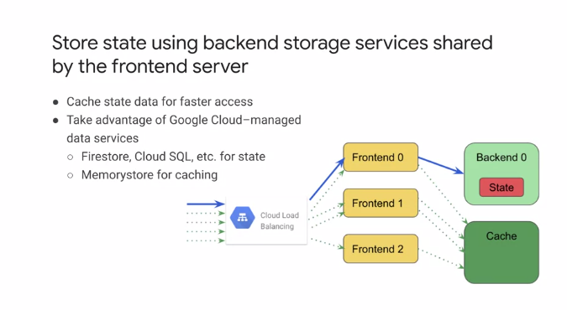

A recognized best practice for designing stateful services is to use backend storage service that are shared by frontend stateless services. For example, for persistent state, the Google Cloud-managed to data services such as firestore or Cloud SQL maybe suitable. Then to improve the speed of data access, the data can be cached. The memorystore, which is a highly available latest best service is ideal for this.

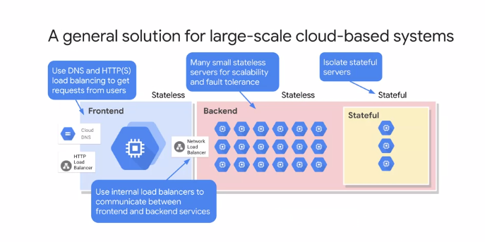

This diagram displays a general solution that shows the separation of the frontend and backend processing stages. A load balancer distributes the load between the backend and frontend services. This allows the backend to scale if it needs to keep up with the demand from the frontend. In addition, the stateful services or servers are also isolated. The stateful services can make use of the persistent storage services and caching as previously discussed. This layout allows a large part of the application to make use of the scalability and fault tolerance of Google Cloud Services as stateless services. By isolation of the stateful servers and services, the challenges of scaling and upgrading are limited to a subset of the overall set of services.

**Microservices Best Practices**

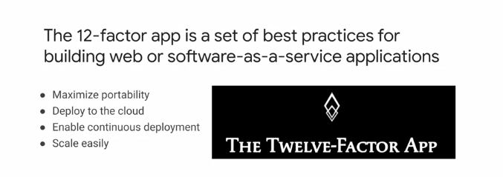

Let's discuss microservice best practices. The 12-factor app is a set of best practices for building web or software as a service applications. The 12-factor design helps you decouple components of the application so that each component can be deployed to the cloud using continuous deployment and scaled up or down seamlessly. The design principles also help maximize portability to different environments. Because the factors are independent of any programming language or software stack, 12-factor design can be applied to a wide variety of applications. Let's take a look at these best practices.

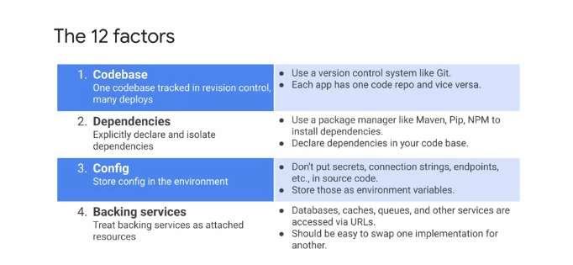

* The first factor is codebase. The codebase should be tracked in a version control such as Git. Cloud Source repositories provide fully featured private repositories.
* The second factor is dependencies. There are two main considerations when it comes to dependencies for 12-factor apps, dependency declaration and dependency isolation. Dependencies should be declared explicitly and stored in version control. Dependency tracking is performed by language specific tools such as Maven for Java and Pip for Python. An application and its dependencies can be isolated by packaging them into a container. Container registry can be used to store the images and provide fine-grained access control.
* The third factor is configuration. Every application has a configuration for different environments like test, production and development. This configuration should be external to the code and usually kept in environment variables for deployment flexibility.
* Fourth factor is backing services. Every backing service such as database, cache or message service should be accessed via URLs and set by configuration. The backing services act as abstractions for the underlying resource. The aim is to be able to swap one backing service for a different implementation easily.

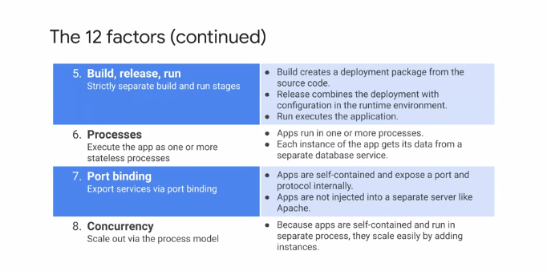

* The fifth factor is build, release, run. The software deployment process should be broken into three distinct stages, built, release and run. Each state should result in an artifact that's uniquely identifiable. Build will create a deployment package from the source code. Every deployment package should be linked to a specific release that's a result of combining a runtime environment configuration with the build. This allows easy road maps and a visible audit trail of the history of every production deployment. The run stage then simply executes the application.
* The sixth factor is processes. Applications run as one or more stateless processes. If state is required, the technique discussed earlier in this module for State Management should be used. For instance, each service should have its own data store and cash using for example Memorystore to cash and share common data between services used.
* The seventh factor is port binding. Services should be exposed using a port number. The applications bundle the web server as part of the application and do not require a separate server like Apache. In Google Cloud, such apps can be deployed on platform services such as Compute Engine, GKE, App Engine or Cloud Run.
* The eight factor is concurrency. The application should be able to scale out by starting new processes and scale back in as needed to meet demand or load.

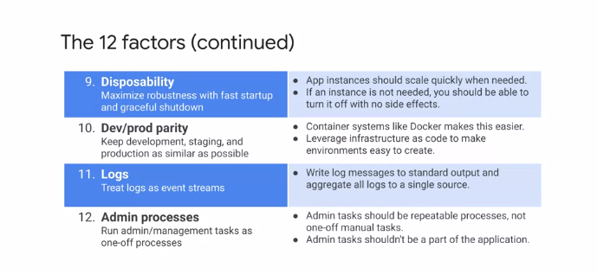

* The ninth factor is disposability, applications should be written to be more reliable than the underlying infrastructure they run on. This means they should be able to handle temporary failures in the underlying infrastructure and gracefully shut down and restart quickly. Applications should also be able to scale up and down quickly, acquiring and releasing resources as needed.
* The tenth factor is development production parity. The aim should be to have the same environments used in development and test or staging as are used in production. The infrastructure as code and Docker containers make this easier. Environments can be rapidly and consistently provisioned and configured via environment variables. Google Cloud provides several tools that can be used to build workflows that keep the environments consistent. These tools include Cloud Source repositories, Cloud Storage, Container Registry and Cloud Deployment Manager. Deployment Manager allows the writing of templates to create deployments using Google Cloud services.
* The 11th factor is logs, logs provide an of the health of your applications. It's important to decouple the collection processing and analysis of logs from the core logic of your apps. Logging should be to standard output and aggregating into a single source. This is particularly useful when your apps require dynamic scaling and are running on public clouds because it eliminates the overhead of managing the storage location for logs. And the aggregation from distributed and often ephemeral VMs or containers. Google Cloud offers a suite of tools that helps with the collection, processing and structured analysis of logs.
* The 12th factor is admin processes. These are usually one-off processes and should be decoupled from the application. These should be automated and repeatable, not manual processes. Depending on your deployment on Google Cloud, there are many options for this including cron jobs in Cloud tasks on App Engine and Cloud Scheduler.

**Rest**

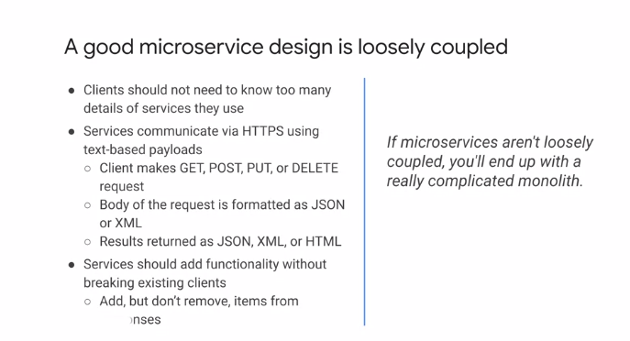

Let's talk about the design of microservices based on rest and HTTP to achieve loosely coupled independent services. One of the most important aspects of microservices based applications is the ability to deploy microservices completely independent of one another. To achieve this independence, each microservice must provide a version well-defined contract to its clients, which are other microservices or applications. Each service must not break these versioned contracts until it's known that no other microservice relies on a particular versioned contract. Remember that other microservices may need to roll back to a previous code version that requires a previous contract. So it's important to account for this fact in your deprecation and turn down policies. A culture around strong versioned contracts is probably the most challenging organizational aspect of a stable microservices based application.

At the lower level of detail, services communicate using HTTPS with text-based payloads, for example, JSON or XML and use the HTTP verbs such as, get and post, to provide meaning for the actions requested. Clients should just need to know the minimal details to use the service. The URI, the request and the response message formats.

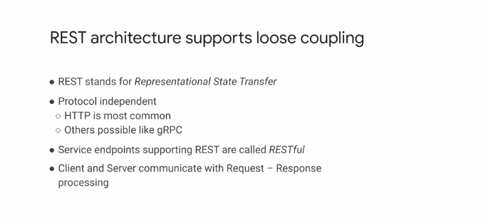

REST architecture supports loose coupling. REST stands for Representational State Transfer. And is protocol independent. The HTTP is the most common protocol but gRPC is also widely used. REST supports loose coupling, but still requires strong engineering practices to maintain that loose coupling. A starting point is to have a strong contract. HTTP-based implementations can use a standard like open API and gRPC provides protocol buffers. To help maintain loose coupling, it is vital to maintain backward compatibility of the contract and to design an API around a domain and not particular use cases or clients. If the latter is the case, each new use case or application will require another special purpose REST API regardless of the protocol. Why request-response processing is the typical use case, streaming may also be required and can influence the choice of protocol. gRPC supports streaming, for example.

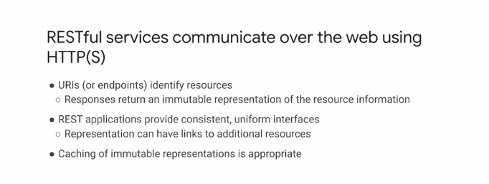

Resources are identified by URIs or endpoints and responses to requests return an immutable representation of the resource information. REST applications should provide consistent uniform interfaces and can link to additional resources. Hypermedia as the engine of application state is a component of REST that allows the client to require little prior knowledge of a service because links to additional resources are provided as part of the responses. It is important that API design is part of the development process. Ideally, a set of API design rules is in place that helps the REST APIs provide a uniform interface. For example, each service reports are consistently, the structure of the URLs is consistent, and the use of paging is consistent. Also consider caching for performance and resource optimization for immutable resources.

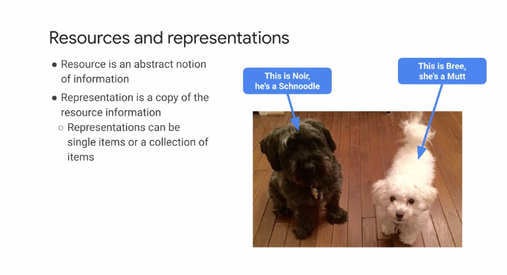

In REST, a client and server exchange representations of resource. A resource is an abstract notion of information. The representation of a resource is a copy of the resource information. For example, a resource could represent a dog. The representation of a resource is the actual data for a particular dog. For example, Noir who is a Schnoodle or Bree who is Mutt. Two different representations of resource. The URI provides access to a resource. Making a request for that resource returns a representation of that resource, usually in JSON format. The resource requested can be single items or a collection of items. For performance reasons returning collection of items, instead of individual items can be beneficial.

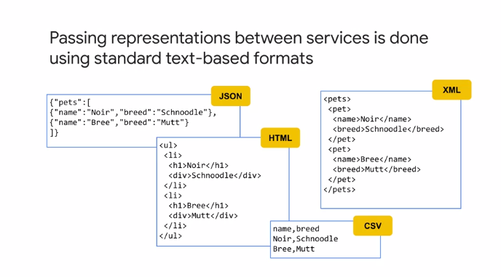

These types of operations are often referred to as batch APIs. Representation of a resource between client and services are usually achieved using text-based standard formats. JSON is the norm for text-based formats, although XML can be used as well. For public facing or external facing APIs, JSON is the standard. For internal services, gRPC may be used, in particular, if performance is key.

**HTTP**

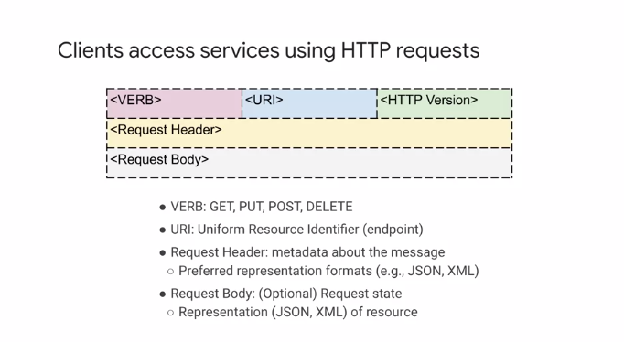

A client accessing HTTP service forms an HTTP request. HTTP requests are built in three parts. The request line, header variables and request body. The request line has the HTTP verb, GET, POST, PUT, etc, the requested URI and the protocol version. The header variables contain key value pairs. Some of these are standards such as user-agent, which helps the receiver identify the requesting software agent. Metadata about the message format or preferred message formats is also included here for HTTPS based REST services. You can add custom headers here. The request body contains data to be sent to the server and is only relevant for HTTP commands that send data such as POST and PUT. Here we see two examples of HTTP client text-based messages. The first example shows an HTTP get request to the URL using HTTP version 1.1. There's one request header variable named host with the value pets.drehnstron.com. The second example shows an HTTP POST request to the URL/add using HTTP version 1.1. There are three request header variables, host, content-type set to JSON, content length set to 35 bytes. There is a request body which has the JSON document name Noir, breed, schnoodle. This is the representation of the pet being added.

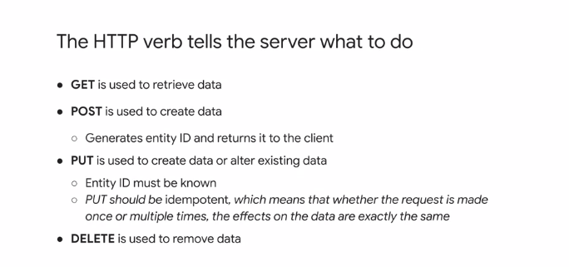

As part of a request, the HTTP verb tells the server the action to be performed on a resource. HTTP as a protocol provides nine verbs, but usually only the four listed here are used in REST. GET is used to retrieve resources. POST is used to request the creation of a new resource. The service then creates the resource and usually returns the unique ID generated for the new resource to the client. PUT is used to create a new resource or make a change to an existing resource. PUT request should be idempotent, which means that no matter how many times the request is made by the client to a service, the effects on the resource are always exactly the same. Finally, a DELETE request is used to remove a resource.

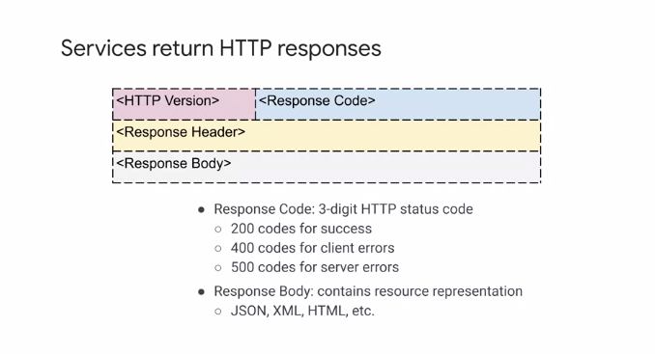

HTTP services return responses in a standard format defined by HTTP. These HTTP responses are built in three parts. The response line, header variables, and response body. The response line has the HTTP version and a response code. The response codes are broken on boundaries around the hundreds. The 200 range means okay. For example, 200 is okay. 201 means a resource has been created. The 400 range means the client request is an error. For example, 403 means forbidden due to request or not having permission. 404 means requested resource not found. The 500 range means the server encountered an error and cannot process the request. For example, 500 is internal server error. 503 is not available usually because the server is overloaded. The response header is a set of key value pairs, such as content type, which indicates to the receiver the type of the content the response body contains. The response body has the resource representation requested in the format specified in the content type header and can be JSON, XML, HTML, etc.

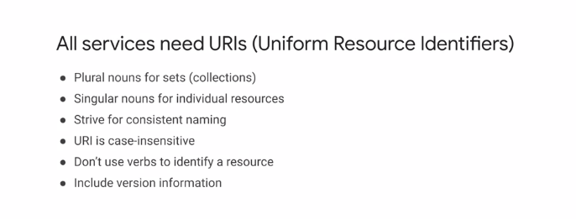

The guidelines listed here focus on achieving consistency on the API. Singular nouns should be used for individual resources and plural nouns for collections or sets. For an example, consider the following URI/pet. Then a GET request for URI/pet/1 should fetch a pet with ID one, whereas GET/pets should fetch all the pets. Do not use URIs such as GET/GET pets. The URI should refer to the resource, not the action on the resource. That is the rule of the verb. Remember that URIs are case insensitive and that they include version information.

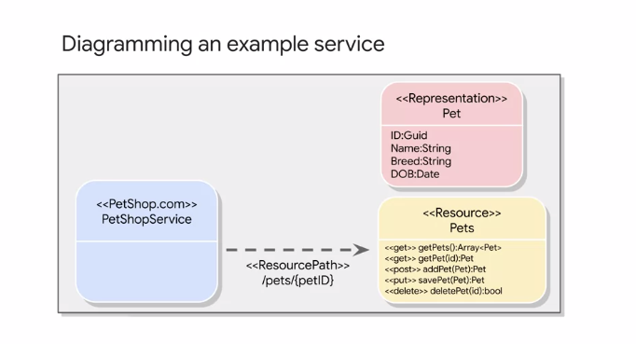

It is a good practice to diagram services. This diagram shows that there is a service that provides access to the resource known as pets. The representation of the resource is the pet. When a request is made for the resource via the service, one or more representations of a pet are returned.

**APIs**

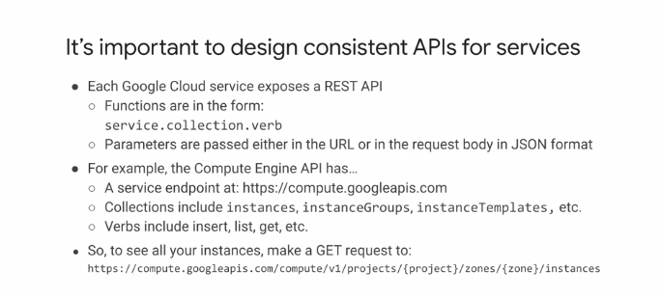

Let's move on to the API design. It is important to design consistent APIs for services. Google provides an API design guide with recommendations on items such as names, error handling documentation, versioning, and compatibility. This guide and the API style book are linked in the slides. For examples of best practices, it is useful to examine the Google Cloud APIs. Each Google Cloud service exposes a REST API. Functions are defined in the form service.collection.verb. The service represents the service endpoint. Example, for the Compute Engine API, the service endpoint is compute.googleapis.com. Collections include instances, instanceGroups, and instanceTemplates. The verbs then include list, GET, and insert, for example. To see all your Compute Engine instances, make a GET request to the link shown on the slide. Parameters are passed either in the URL or on the request body in JSON format.

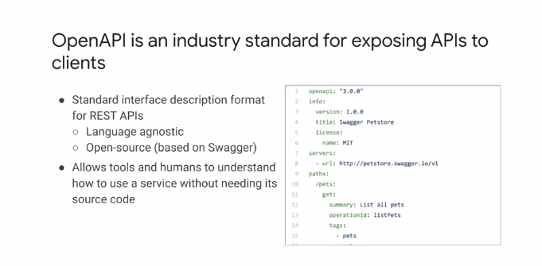

OpenAPI is an industry standard for exposing APIs to clients. Version 2.0 of the specification was known as Swagger. Swagger is now a set of open-source tools built around OpenAPI that with associated tool link supports designing, building, consuming, and documenting APIs. OpenAPI supports an API first approach. Designing the API through OpenAPI can provide a single source of truth from which source code for client libraries and server stubs can be generated automatically, as well as API user documentation. OpenAPI is supported by Cloud Endpoints and Apigee. The example document shows a sample of an OpenAPI specification of a pet store service. The URI is petstore.swagger.io/v1. Note the version in the URI here. The example then shows an endpoint/pets, which is accessed using the HTTP verb GET, and will provide a list of all pets.

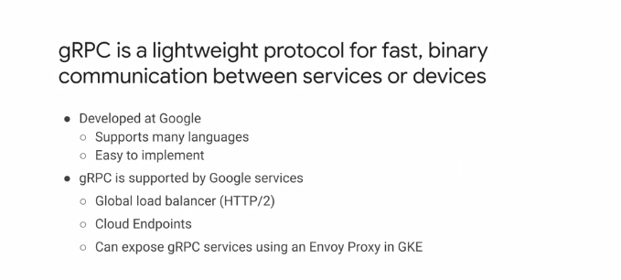

Developed at Google, gRPC is a binary protocol that is extremely useful for internal microservice communication. It provides support for many programming languages, has strong support for loose coupling via contracts defined using protocol buffers, and is high-performing because it's a binary protocol. It is based on HTTP/2 and supports both client and server streaming. The protocol is supported by many Google Cloud services, such as the global load balancer and Cloud Endpoints for microservices, as well as on GKE by using an Envoy Proxy.

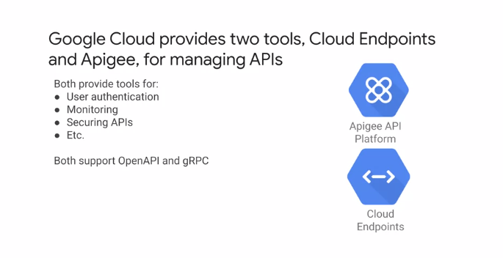

Google Cloud provides two tools for managing APIs, Cloud Endpoints and Apigee. Cloud Endpoints is an API management gateway which helps you develop, deploy, and manage APIs on any Google Cloud backend. It runs on Google Cloud and leverages a lot of Google's underlying infrastructure. Apigee is an API management platform built for enterprises with deployment options on Cloud, on-premises, or hybrid. The feature set includes an API gateway, customizable portal for on-boarding partners and developers, monetization, and deep analytics around APIs. You can use Apigee for any HTTP, HTTPS backends, no matter where they are running on-premises, any public Cloud, etc. Both solutions provide tools for services such as user authentication, monitoring, and securing, and also for OpenAPI and gRPC.

**Continuous Integration Pipelines**

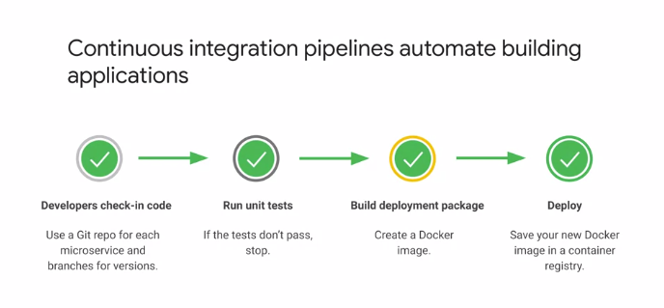

Let's begin by talking about continuous integration pipelines. Continuous integration pipelines automate building applications. This graphic shows a very simplistic view of a pipeline which would be customized to meet your requirements. The process starts with checking code into a repository where all the unit tests are run. On successful passing of the tests, a deployment package is built as a Docker image. This image is then saved in a container registry from where it can be deployed. Each microservice should have its own repository. Typical extra steps include linting of code, quality analysis by tools such as SonarQube, integration tests, generating tests reports, and image scanning.

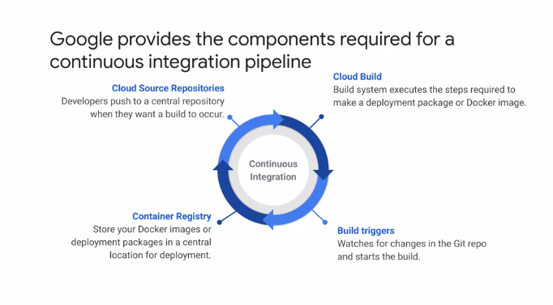

Google Cloud provides the components required to build a continuous integration pipeline. Let's go through each of these. The Cloud Source Repositories service provides private Git repositories hosted on Google Cloud. These repositories let you develop and deploy an app or service in a space that provides collaboration and version control for your code. Cloud Source Repositories is integrated with Google Cloud, so it provides a seamless developer experience. Cloud Build executes your builds on Google Cloud infrastructure. It can import source code from Cloud Storage, Cloud Source Repositories, GitHub or Bitbucket, executability to your specification and produce artifacts such as Docker containers or Java Archives. Cloud Build executes your build as a series of build steps, where each build step is run in a Docker container. A build step can do anything that can be done from a container irrespective of the environment. There are standard steps or you can define your own steps. A Cloud Build trigger automatically starts a build whenever you make any changes to your source code. You can configure the trigger to build your code on any changes to the source repository or only changes that match that certain criteria. Container Registry is a single place for your team to manage Docker images or Deployment packages, perform vulnerability analysis, and decide who can access what with fine-grained access controls. Let's go through each of these services in more detail. Cloud Source Repositories provide managed Git repositories. You can use Cloud IAM to add team members to your project and to grant them permission to create, view, and update repositories. Repositories can be configured to publish messages to a specific pub/sub topic. Messages can be published when a user creates or deletes a repository or pushes a commit. Some other features of Cloud Source Repositories include the ability to debug introduction using Cloud Debugger, audit logging to provide insights into what actions were performed, where and when, and direct deployment to App Engine. It is also possible to connect an existing GitHub or Bitbucket repository to Cloud Source Repositories. Connected repositories are synchronized with Cloud Source Repositories automatically. Cloud Build lets you build software quickly across all languages. It is a Google-hosted Docker build service and is an alternative to using the Docker build. The CLI can be used to submit a build using gcloud. An example is shown on this slide. Gcloud builds submit submits the build and will run as a remote build. The --tag is the tag to use when the image is created. The tag must use the gcr.io or *.gcr.io.*namespace. Your source must contain a Docker file if you use the tag. Finally, the dot represents the location of the source to build. Build triggers watch a repository and build a container whenever code is pushed. Google's Build triggers support Maven, Cloud builds, and Docker. A Cloud Build trigger automatically starts a Build whenever a change is made to source code, it can be set to start a Build on commits to a particular branch or on commits that contain a particular tag. You can specify a regular expression with the branch or tag value to match. The Build configuration can be specified either in a Docker file or a Cloud Build file. The configuration required is shown on this slide. First, a source is selected. This can be Cloud Source Repositories, GitHub or Bitbucket. In the next stage, a Source Repository is selected followed by the trigger settings. The trigger settings include information like the branch or tag to use for trigger and the Build configuration, for example, the Docker file or Cloud Build file. Container Registry is a Google Cloud-hosted Docker Repository. Images built using Cloud Build are automatically saved in Container Registry. Images are tagged with a prefix as shown on this slide. It is also possible to push and pull images using the standard Docker commands. So to push an image, use docker push gcr.io/your-project-id/image-name. To pull an image, use docker pull gcr.io/your-project-id/image-name.

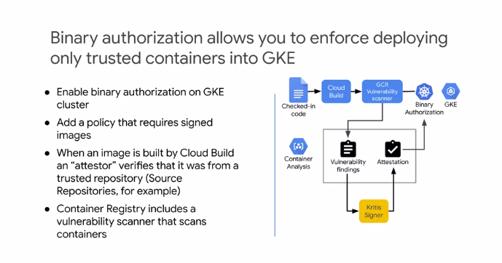

Now, binary authorization allows you to enforce deployment of only trusted containers into GKE. Binary authorization is a Google Cloud service and is based on the Kritis specification. For this to work, you must enable binary authorization on your GKE cluster where your deployment will be made. A policy is required to sign the images. When an image is built by Cloud Build and attestor verifies that it was from a trusted repository. For example, Source Repositories. Container Registry includes a vulnerability scanner that scans containers. A typical workflow is shown in the diagram. Check in of code triggers a Cloud Build. As part of the Build, Container Registry will perform a vulnerability scan when a new image is uploaded, the scanner publishes messages to pub/sub. The Kritis signer listens to pub/sub notifications from a Container Registry vulnerability scanner and makes an attestation if the image scanning passed the vulnerability scan. Google Cloud binary authorization service then enforces the policy requiring attestations by the Kritis signer before a container image can be deployed. This flow prevents deployment of images with vulnerabilities below a certain threshold.

**Infrastructure as Code**

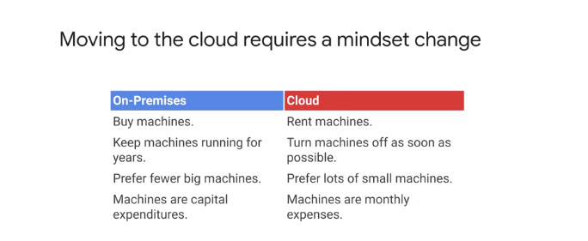

Let's now move on to consider Infrastructure as Code. Moving to the Cloud requires a mindset change. The on-demand pay-per-use model of Cloud computing is a different model to traditional on-premise infrastructure provisioning. A typical on-premise model would be to buy machines and keep them running continuously. The Compute Infrastructure is typically built from fewer larger machines. From an accounting view, the machines are capital expenditure that deprecates over time. When using the Cloud, resources are rented instead of purchased, and as a result, we want to turn the machines off as soon as they are not required to save on cost. The approach is to typically have lots of smaller machines scale out instead of scale up, and to expect an engineer for failure. From an accounting view, the machines are a monthly operating expenditure.

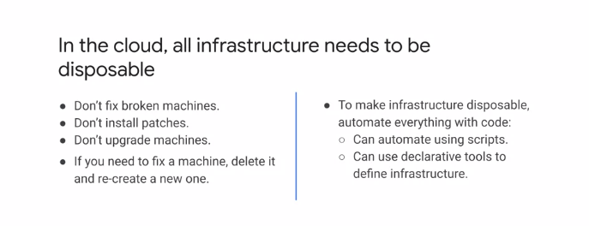

In other words, in the Cloud, all infrastructure needs to be disposable. The key to this is Infrastructure as Code, IaC, which allows for provisioning, configuration, and deployment activities to be automated. Having the process automated minimizes risks, eliminates manual mistakes, and supports repeatable deployments, scale, and speed. Deploying one or 100 machines is the same effort. The automation can be achieved using scripts or declarative tools such as Terraform, which we will discuss later. It is really important that no time is spent trying to fix broken machines, or installing patches, or upgrades. These will lead to problems recreating the environment at a later date. If a machine requires maintenance, remove it and create a new one instead. Costs can be reduced by provisioning ephemeral environments such as test environments that replicate the production environment.

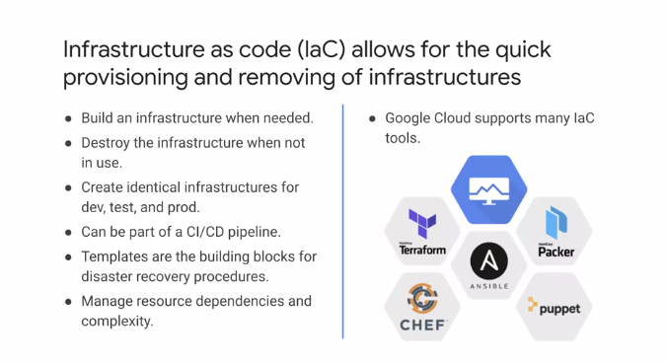

In essence, Infrastructure as Code allows for the quick provisioning and removing of infrastructure. The on-demand provisioning of a deployment is extremely powerful. This can be integrated into a continuous integration pipeline, smooths the path to continuous deployment. Automated infrastructure provisioning means that it can be provisioned on demand and the deployment complexity is managed in code. This provides the flexibility to change infrastructure as requirements change, and all the changes are in one place. Infrastructure for environments such as deployment and test can now easily replicate production and can be deleted immediately when not in use, all because of Infrastructure as Code. Several tools can be used for IaC. Google Cloud provides deployment manager where deployments are described in a YAML file known as Configuration. This details all the resources that should be provisioned. Configurations can be modularized using templates, which allows the abstraction of resources into reusable components across deployments. In addition to deployment manager, Google Cloud also provides support for other IaC tools including Terraform, CHEF, Puppet, Ansible, and Packer. Let's take a closer look at deployment manager and Terraform.

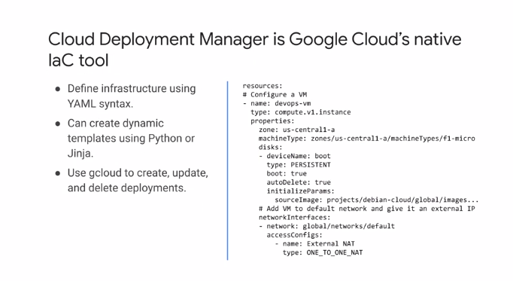

Cloud Deployment Manager defines infrastructure using YAML files. Templates allow the separation of configuration into different pieces that can be used and reused across different deployments. These templates can be specific or more generalized. They can make use of template properties, environment variables, and modules to create dynamic configuration and template files. The template files can be written in Python or Jinja, the Python templating language. Deployments can be created using the Google Cloud Console, APIs, or GCloud. The example YAML snippet to the right shows a section from a deployment manager configuration. The configuration must list resources, which in this example is a virtual machine, including the type of VM, zone, disk, and network interface.

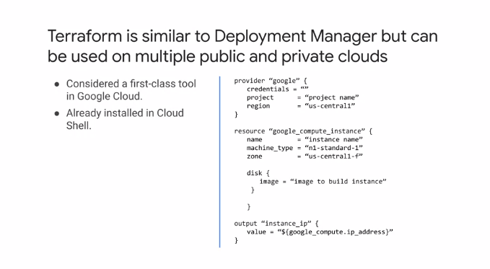

Terraform is similar to deployment manager, but can be used on multiple public and private Clouds. Terraform is already installed in Cloud Shell. The example configuration files shown on the right begins by indicating that the provider is Google Cloud. What follows is the configuration of a compute engine instance and its disk. The output section allows for the IP address of the provisioned instance to be obtained from the deployment.

**Key Storage Characteristics**

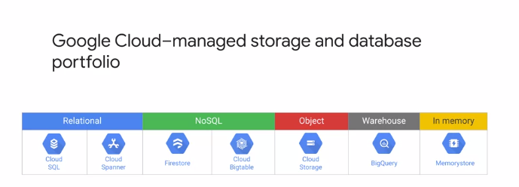

Let's get started by considering key storage characteristics. Google Cloud has a wide range of managed storage and database options in its portfolio. Knowing the characteristics of each and being able to select a suitable solution is vital as an architect during the design process. From a high-level the services range from relational NoSQL object storage, data warehouse, to In memory. These services are fully managed to scalable and backed by industry leading SLAs. Making a decision on which storage solution is right for your requirements is a balance of a number of characteristics including the type of data, scale, durability, availability, and location requirements. We will discuss ways in which you can make the decision based on your requirements in this module.

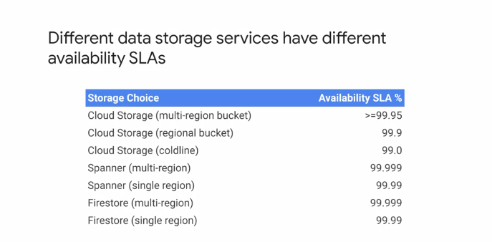

Different data storage services have different availability SLAs. For a service, the availability SLA is often dependent on the configuration of the service. For example, for Cloud storage as the slide shows the availability varies depending on whether multi-regional, regional or coldline buckets are created. The same can be seen for Cloud Spanner and Firestore with multi-region offerings higher availability than single region configurations. This is where requirements are extremely important as they will help inform the storage choices. The availability SLAs are typically defined per month. Monthly uptime percentage means the total number of minutes in a month, minus the number of minutes of downtime suffered from all downtime periods in a month, divided by the total number of minutes in a month. For up-to-date SLA numbers refer to the documentation.

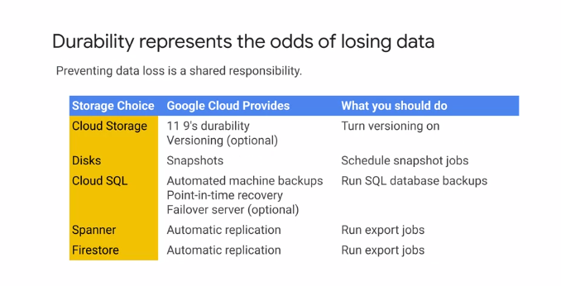

Now durability of data represents the odds of losing the data. Depending on the storage solution, the durability is a shared responsibility. Google Cloud responsibility is to ensure that data is durable in the event of a hardware failure. Your responsibility is performing backups of your data, for example Cloud storage provides you with 11 9's durability and versioning is a feature. However, it's your responsibility to determine when to use versioning. I recommend turning versioning on and having older versions archived as part of an object lifetime management policy. For other storage services to achieve durability, it usually means taking backups of data. For disks this means snapshots. So snapshot jobs should be scheduled. For Cloud SQL, Google Cloud provides automated machine backups, point-in-time recovery, and optionally a failover server. To improve durability SQL database backup should also be run. Spanner and Firestore provide automatic replication and you should run export jobs with the data being exported to Cloud storage.

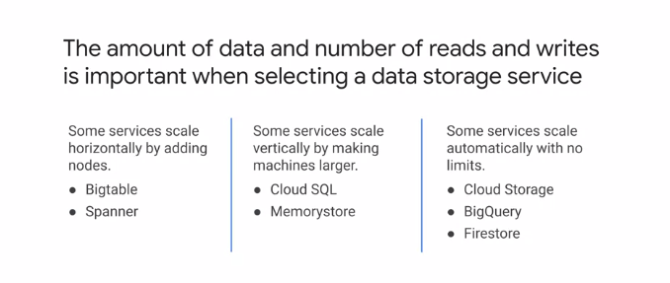

The amount of data and the number of reads and writes are important to know when selecting a data storage service. Some services scale horizontally by adding nodes, for example, Bigtable and Spanner which is in contrast to Cloud SQL and Memorystore which scale machines vertically. Other services scale automatically with no limits for example, Cloud storage BigQuery, and Firestore.

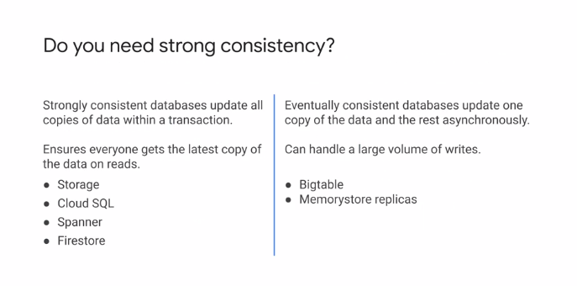

Strong consistency is another important characteristic to consider when designing data solutions. A strongly consistent database will update all copies of data within a transaction and ensure that everybody gets the latest copy of committed data on reads. Google Cloud Services providing strong consistency include Cloud storage, Cloud SQL, Spanner, and Firestore. Eventual consistent data bases typically have multiple copies of the same data for performance and scalability. They support handling large volumes of rights. They operate by updating one copy of the data synchronously and all copies asynchronously. Which means that not all readers are guaranteed to read the same value at a given point in time. The data will eventually become consistent but not immediately. Bigtable and Memorystore are examples of Google Cloud data services that have eventual consistency.

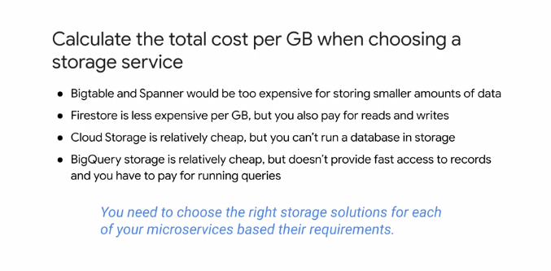

When designing a data storage solution, calculating the total cost per GB is important to help determine the financial implications of a choice. Bigtable and Spanner are designed for massive data sets and are not as cost effective for small data sets. Firestore is less expensive per GB stored, but the cost for reads and writes must be considered. Cloud storage is not as expensive, but is only suitable for certain data types. BigQuery storage Is relatively cheap but does not provide fast access to records and a cost is incurred for each query. So as you see the choice of the right storage solution is not simple. It has to be based on the type of data, size of data, and read/write patterns.

**Choosing Google Cloud Storage and Data Solutions**

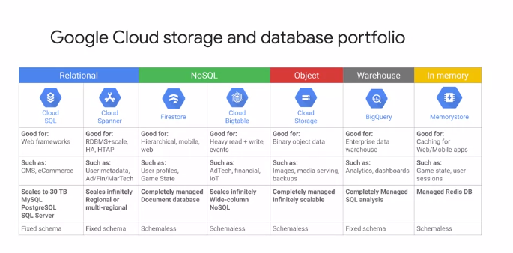

Now that you've documented the data characteristics of your services, let's talk about how to select Google Cloud Storage and Data Solutions. The Google Cloud Storage and Database portfolio covers relational NoSQL, Object, Data Warehouse, and In-memory stores as shown in this table. Let's discuss each service from left to right. Cloud SQL is a fixed schema datastore with a storage limit of 30 terabytes. It is offered using MySQL, Postgres SQL, and SQL Server. These services are good for Web applications such as CMS or e-commerce. Cloud Spanner is also relational and fixed schema but scales infinitely and can be regional or multi-regional. Example use case include scalable relational databases greater than 30 GB with high availability, and also global accessibility like supply chain management and manufacturing. Google Cloud's NoSQL datastores are schemaless. Firestore is a completely managed document datastore with maximum document size of 1 MB, it is useful for hierarchical data. For example, a game state of user profiles. Cloud Bigtable is also a NoSQL Datastore that scales infinitely. It is good for heavy read and write events and use cases including financial services, Internet of Things, and digital ad streams. For Object Storage, Google Cloud offers Cloud Storage. Cloud Storage is schemaless and is completely managed with infinite scale. It stores binary object data, and so it's good for storing images, media serving, and backups. Data. Warehousing is provided by BigQuery. The storage uses a fixed schema and supports completely managed SQL analysis of the data stored. It is excellent for performing analytics and business intelligence dashboards. For In Memory storage, Memorystore provides a schemaless managed Redis database. It is excellent for caching for Web and mobile apps and for providing fast access to state in microservice architectures.

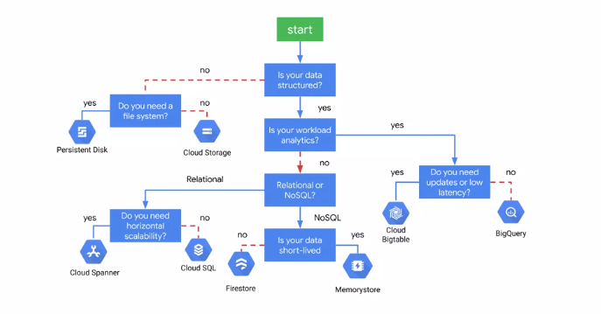

If you prefer flowcharts, leverage this chart when selecting a storage or database service. First, ask yourself if your data is structured. If it isn't, you will want to choose persistent disk or Cloud Storage depending on whether you need a file system. If your data is structured, ask yourself whether your workload focuses on analytics. If it does, you will want to choose Cloud Bigtable or BigQuery, depending on your latency and update needs. Otherwise, check whether your data is relational. If it's not relational, choose Firestore or Memorystore, depending on whether your data is short-lived. If your data is relational, you will want to choose Cloud SQL or Cloud Spanner depending on your need for horizontal scalability. In general, choosing a datastore is about trade-offs. Ideally, there would be low-cost, globally scalable, low latency, strongly consistent databases. In the real world, trade-offs must be made, and this flowchart helps you decide on those trade-offs and how they map to a solution.

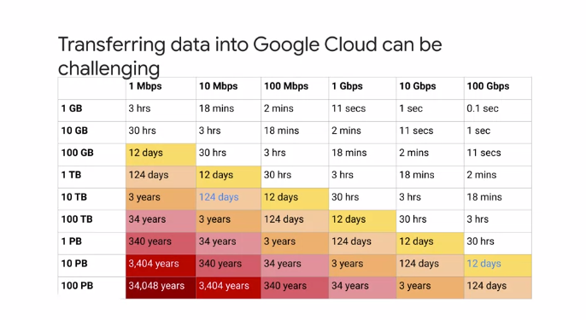

You might also want to consider how to transfer data in Google Cloud, a number of factors must be considered, including cost, time, offline versus online transfer options, and security. While transfer into Cloud storage is free, there will be costs with the storage of the data and maybe even appliance costs if a transfer appliance is used or egress costs if transferring from another Cloud provider. If you have huge datasets, the time required for transfer across a network may be unrealistic. Even if it is realistic, the effects on your organization's infrastructure may be damaging while the transfer is taking place. This table shows the challenge of moving large datasets. For example, if you have 1 TB of data to transfer over a 100 Mbps connection, it will take about 12 days to transfer the data. The color-coded cells highlight unrealistic timelines that require alternative solutions. Let's go over online and offline data transfer options.

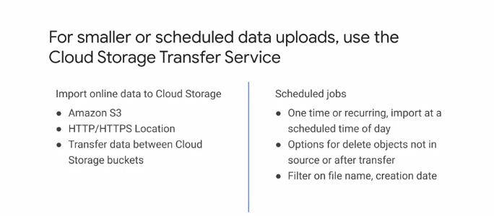

For smaller or scheduled data uploads, use the Cloud Storage Transfer Service, which enables you to move or backup data to a Cloud Storage bucket from other cloud storage providers such as Amazon S3, from your On-premise storage or from any HTTP, HTTPS location. Move data from one Cloud Storage bucket to another so that it is available to different groups of users or applications. Periodically move data as a part of data processing pipeline or analytical workflow. Storage Transfer Service provides options that make data transfer and synchronization easier. For example, you can schedule one-time transfer operation or recurring transfer operations. Delete existing objects in the destination bucket if they don't have a corresponding object in the source, delete data source objects after transferring them, schedule periodic synchronizations from a data source to a data sink with advanced filters based on file creation dates, filename filters, and the times of day you prefer to import data.

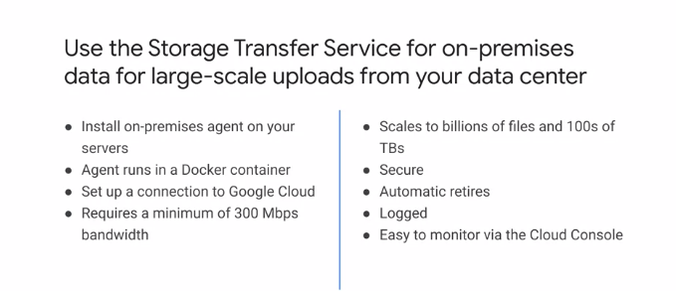

Use the Storage Transfer Service for On-prem data for large-scale uploads from your datacenter. The Storage Transfer Service for On-premises data allows large-scale online data transfers from On-premises Storage to Cloud Storage. With this service, data validation, encryption, error retries and fault tolerance are built in. On-premises software is installed on your servers. The agent comes as a Docker container and a connection to Google Cloud is setup. Directories to be transferred to Cloud Storage are selected in the Cloud Console. Once data transfer begins, the service will pattern allies the transfer across many agents supporting scale to billions of files and hundreds of TB's, via the Cloud console, a user can view detailed transfer logs and also the creation, management and monitoring of transfer jobs. To use the Storage Transfer Service for On-premises, a POSIX compliant source is required and a network connection of at least 300 Mbps. Also a Docker supported Linux server that can access the data to be transferred is required with ports 80 and 443 open for outbound connections. The use case is for On-premises transfer of data whose size is more than one TB.

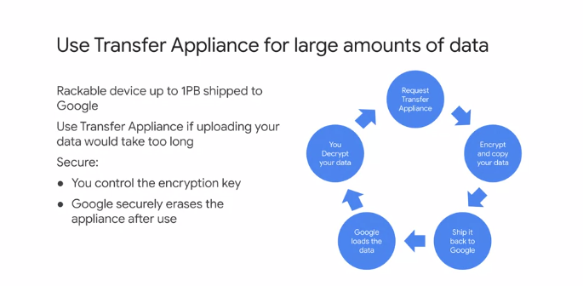

For large amounts of On-premises data that would take too long to upload, use Transfer Appliance. Transfer Appliance is a secure, rackable, high-capacity storage server that you setup in your data center. You fill it with data and ship it to an ingest location where the data is uploaded to Google. The data is secure, you control the encryption key and Google erases the appliance after the transfer is complete. The process for using a Transfer Appliance is that you request an appliance and it is shipped in a tamper-evident case, data is transferred to the appliance, the appliance is shipped back to Google, data is loaded to Cloud Storage and you are notified that it is available. Google uses tamper-evident seals on the shipping cases to and from the data ingest site, data is encrypted to AES-256 standard at the moment of capture. Once the transfer is complete, the appliance is erased per NIST-800-88 standards. You decrypt the data when you want to use it.

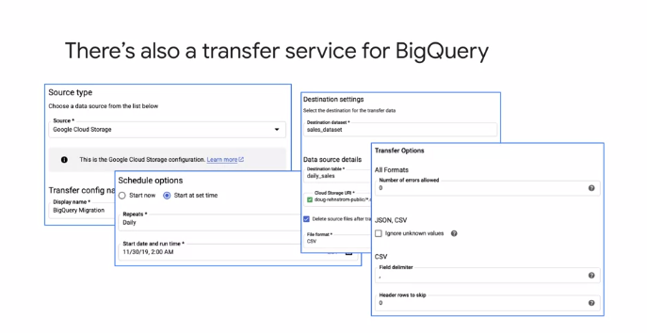

There's also a transfer service for BigQuery. The BigQuery Data Transfer Service automates data movements from SaaS applications to BigQuery on a scheduled managed basis. The Data Transfer Service initially supports Google application sources like Google ads, Campaign Manager, Google Ad Manager, and YouTube. There are also data connectors that allow easy data transfer from Teradata, Amazon Redshift, and Amazon S3 to BigQuery. The screenshots on the slide show that a source type is selected for a transfer, a schedule is configured, and a data destination is selected. For the transfer, the data formats are also configured.

**Designing Google Cloud Networks**

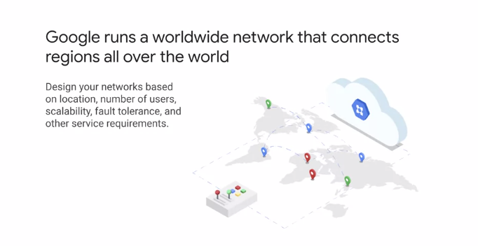

Let's get started by designing Google Cloud Networks and load balancers. Google runs a worldwide network that connects regions all over the world. You can use this high bandwidth infrastructure to design your Cloud networks to meet your requirements such as location, number of users, scalability, fault tolerance, and latency. Let's take a closer look at Google Cloud's network.

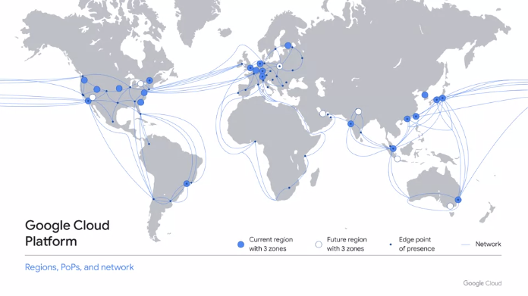

This map represents Google Cloud's reach. On a high level, Google Cloud consists of regions which are the icons and blue, points of presence or Pops, which are the dots in gray, a global private network, which is represented by the blue lines, and services. A region is a specific geographical location where you can run your resources. This map, it shows several regions that are currently operating as well as future regions and their zones. As of this recording, there are 21 regions and 64 zones. The pops, our Google's network is connected to the rest of the Internet. Google Cloud can bring its traffic closer to its peers because it operates an extensive global network of interconnection points. This reduces costs and provides users with a better experience. The network connects regions and pops, and is composed of a global network of fiber optic cables with several submarine cable investments.

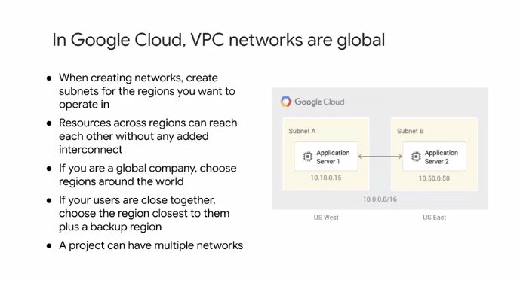

In Google Cloud, VPC networks are global, and you can either create automotive networks and have one subnet per region, or create your own customer network where you get to specify which region to create a subnet in. Resources across regions can communicate using their internal IP addresses without any added interconnect. For example, the diagram on the right shows two subnets in different regions with a server on each subnet. They can communicate with each other using their internal IP addresses because they are connected to the same VPC network. Selecting which regions to create subnets in depends on your requirements. For example, if you are a global company, you will most likely create subnetworks in regions across the world. If users are within a particular region, it may be suitable to select just one subnet in a region closest to these users and maybe a backup region close by. Also, you can have multiple networks per project. These networks are just a collection of regional subnetworks or subnets.

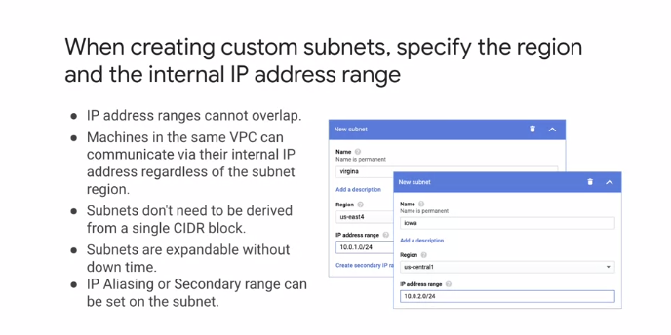

To create custom subnets, you specify the region and the internal IP address range as illustrated in the screenshots on the right. The IP ranges of the subnets don't need to be derived from a single side or block, but they cannot overlap with other subsets of the same VPC network. This applies to primary and secondary ranges. Secondary ranges allow you to define alias IP addresses. Also, you can expand the primary IP address space of any subnets without any workload shutdown or down time. Once you've defined your subnets, machine in the same VPC network can communicate with each other through their internal IP address regardless of the subnets they're connected to.

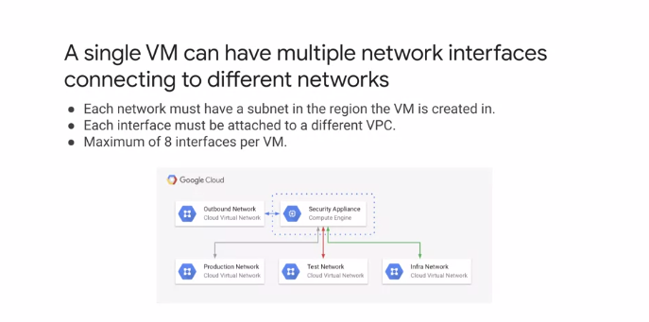

Now, a single VM can have multiple network interfaces connecting to different VPC networks. This graphic illustrates an example of a Compute Engine instance connected to four different networks covering production, test, Infra, and an outbound network. A VM must have at least one network interface, but can have up to eight depending on the instance type and the number of VCP use. A general rule is that with more VCP use, more network interfaces are possible. All of the network interfaces must be created when the instance is created, and each interface must be attached to a different network.

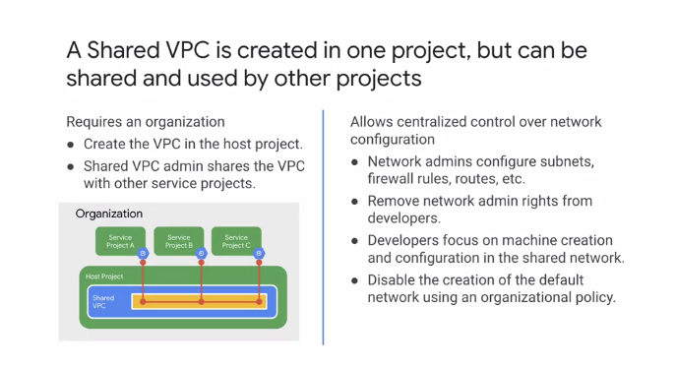

Shared VPC allows an organization to connect resources from multiple projects of a single organization to a common VPC network. This allows the resources to communicate with each other securely and efficiently using internal IPs from that network. This graphic shows a scenario where a shared VPC is used by three other projects namely: service projects A, B, and C. Each of these projects has a VM instance that is attached to the shared VPC. Shared VPC is a centralized approach to multi-product networking because security and network policy occurs in a single designated VPC network. This allows for network administrators rights to be removed from developers so that they can focus on what they do best. Meanwhile, organization network administrators maintain control of resources such as subnets, firewall rules, and routes, while delegating the control of creating resources such as instances to service project administrators or developers.

**Designing Google Cloud load balancers**

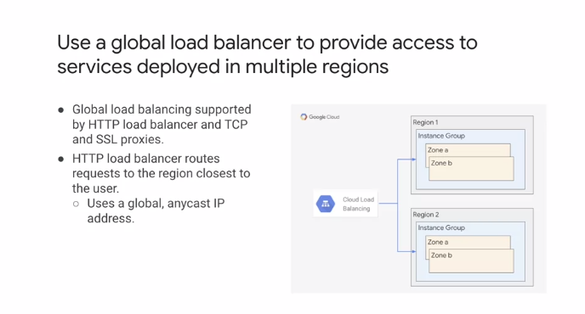

Let's talk about load balancers. Global load balancers provide access to services deployed in multiple regions. For example, the load balancer shown on this slide has a backend with two instance groups deployed in different regions. Cloud load balancing is used to distribute the load among these instance groups. Global load balancing is supported by HTTP load balancers and TCP and SSL proxies in Google Cloud. For an HTTP load balancer, a global anycast IP address can be used simplifying DNS lookup. By default, requests are routed to the region closest to the requester.

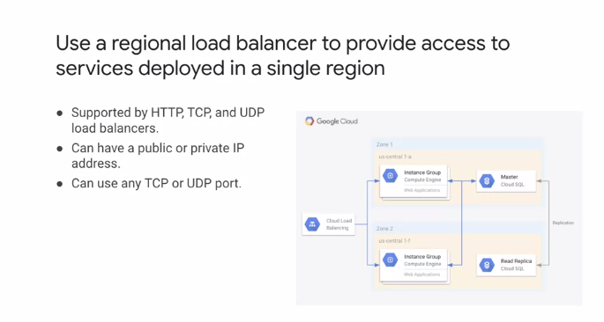

For services deployed in a single region, use a regional load balancer. This graphic illustrates resources deployed with a single region and Cloud load balancing routing requests to these resources. Regional load balancers support HTTP and any TCP or UDP port. If your load balancers have public IP addresses, traffic will likely be traversing the Internet.

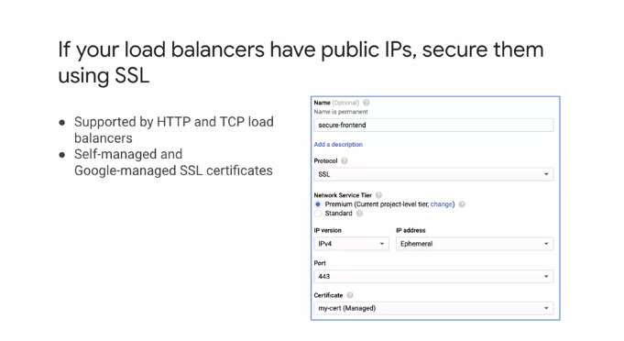

I recommend securing this traffic with SSL which is available for HTTP and TCP load balancers as shown in the screenshot on the right. You can use either self-managed SSL certificates or Google managed SSL certificates when using SSL.

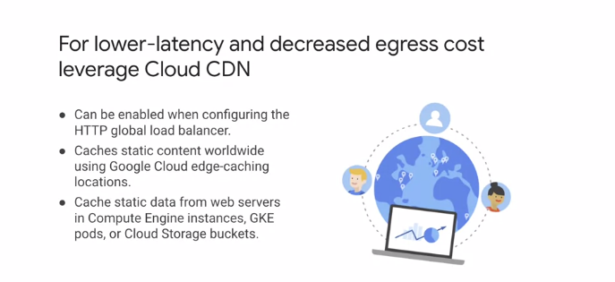

Now, if you are using HTTPS load balancing, you should leverage Cloud CDN to achieve lower latency and decrease egress costs. You can enable Cloud CDN by simply checking the box when configuring an HTTP global load balancer. Cloud CDN caches content across the world using Google Cloud's edge-caching locations. This means that content is cached closest to the user making the requests. The data that is cached can be from a variety of sources, including Compute Engine instances, GKE pods, or Cloud Storage buckets.

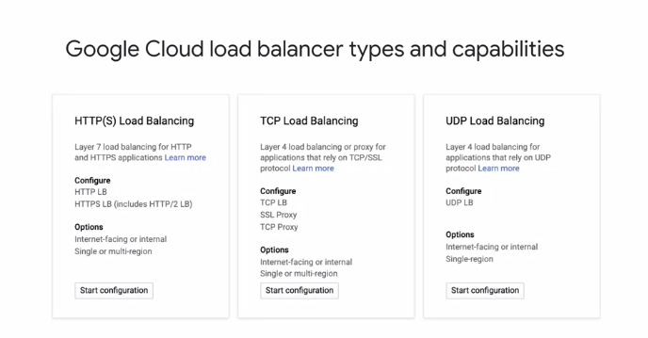

Let me recap this discussion on Google Cloud load balancers and summarize the types and their capabilities. At a high level, load balances can work with internal or external IP addresses. We refer to external IP addresses as Internet-facing. The load balancers can be regional or multi-regional. And finally, they support different traffic types, HTTP, TCP, and UDP. Let's review these starting with the traffic type.

HTTPS Load Balancing is a Layer 7 load balancer. Support is provided for HTTP and HTTPS including HTTP/2. The load balancing supports both Internet-facing, and internal load balancing, as well as regional or global. TCP Load Balancing provides Layer 4 balancing or proxy for applications that require TCP/SSL protocol. You can configure a TCP Load Balancer, or a TCP, or SSL proxy.

TCP Load Balancing supports both Internet-facing, and internal load balancing, as well as regional and global.

UDP Load Balancing is for those applications that rely on UDP as a protocol. The UDP Load Balancer supports both Internet-facing, and internal load balancing, but only regional traffic.

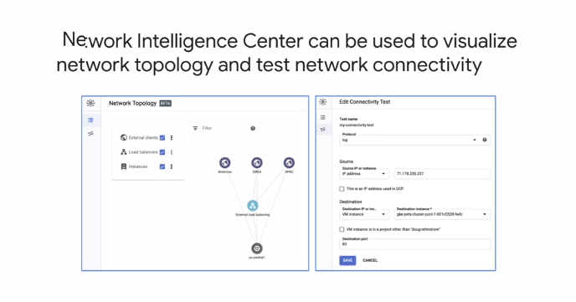

As part of our discussion of designing VPC networks, I also want to mention the Network Intelligence Center. The Network Intelligence Center is a Google Cloud service that can be used to visualize your VPC network topology and test network connectivity.

The left-hand graphic shows a simple network topology visualization with external clients in three different regions, and traffic routed through an external load balancer to resources in US Central one. This facility is extremely valuable for confirming the network topology when configuring a network or when performing diagnostics. The right-hand graphic shows the configuration of a connectivity test between a source and destination along with a protocol and port.

The following tests can be performed. Between source and destination and points in your VPC network. From your VPC Network to and from the Internet. And from your VPC network to and from your on-premises network.

**Connecting Networks**

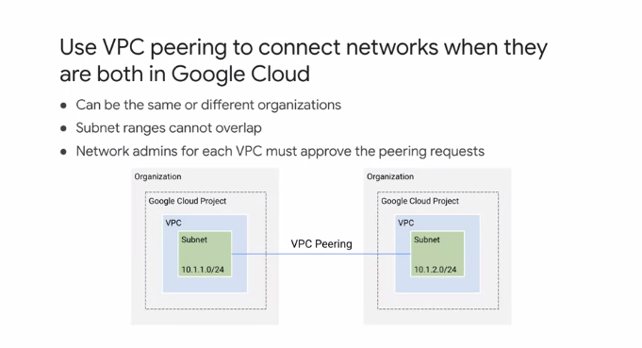

Let's focus our attention on Google Cloud Network connectivity products, which are Peering, Cloud VPN, and Cloud Interconnect.

If you're trying to connect to VPC networks, you might want to consider VPC peering. VPC peering allows private RFC 1918 connectivity across two networks regardless of whether they belong to the same project or even the same organization. Now, remember that each VPC network will have firewall rules that define what traffic is allowed or denied between the networks. This diagram shows a VPC peering connection between two networks belonging to different projects and different organizations. You might notice that the separate ranges do not overlap. This is a requirement for a connection to be established. Speaking of the connection, network administrators for each VPC network must configure a VPC peering request for a connection to be established.

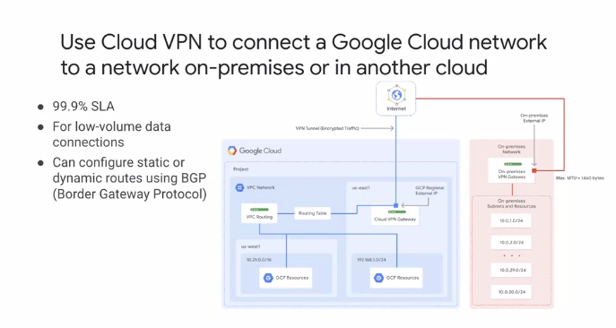

If you're trying to connect a VPC network with an on-premises network or with another Cloud network, you might want to consider Cloud VPN. Cloud VPN securely connects two networks through an IPSec VPN tunnel. Traffic traveling between the two networks is encrypted by one VPN gateway, then decrypted by the other VPN gateway. This protects your data as a travels over the public Internet, and that's why Cloud VPN is useful for low volume data connections, specifically up to three gigabits per second. This diagram shows a simple VPN connection between your VPC and on-premises network. Your VPC network has subnets in us-east1 and us-west1, with Google Cloud resources in each of those regions. These resources are able to communicate using the internal IP addresses because routing within a network is automatically configured, assuming that firewall rules allow the actual communication. This VPN setup is referred to as classic VPN, and it has a 99.9 percent monthly uptime SLA. Classic VPN gateways have a single interface, a single external IP address, and support tunnels using static routing or dynamic routing like BGP.

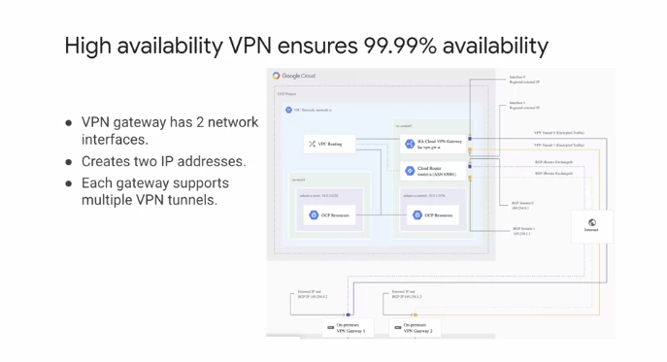

In order to ensure a 99.99 percent monthly uptime SLA, you can also configure a high availability or HA VPN. For an HA VPN two network interfaces and two external IP address are required on-premises, as illustrated on this slide. In this topology, one HA Cloud VPN gateway connects to two peer devices. Each peer device has one interface and one public IP address. The HA VPN gateway uses two tunnels, one tunnel to each peer device. This protects against failure of one device and allows upgrade of a device individually.

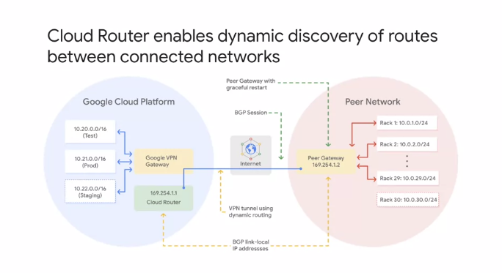

I mentioned earlier that Cloud VPN supports both static and dynamic routes. In order to use dynamic routes, you need to configure Cloud Routers. A Cloud Router can manage routes for a Cloud VPN tunnel using border gateway protocol or BTP. This routing method allows her routes to be updated and exchanged without changing the tunnel configuration. This allows for new subnets like staging in the VPC network and Rack 30 in the peer network to be seamlessly advertised between networks.

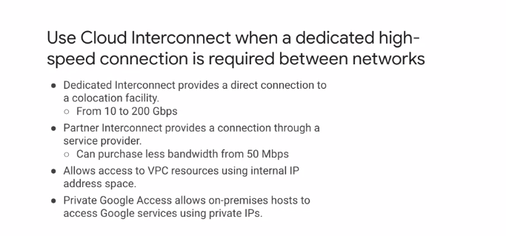

If you need a dedicated high-speed connection between networks, consider Cloud Interconnect. Cloud Interconnect has two options for extending on-premises networks, Dedicated Interconnect and Partner Interconnect. Dedicated Interconnect provides a direct connection to a co-location facility. The co-location facility must support either 10 gigabits or 100 gigabit circuits. A dedicated connection can bundled up to 8-10 gigabits connections or to 100 gigabits connections for a maximum of 200 gigabits per second. Partner Interconnect provides a connection through a service provider. This can be useful for lower bandwidth requirements starting from 50 megabits. In both cases, Cloud Interconnect allows access to VPC resources using an internal IP address space. You can even configure private Google access for on-premises hosts to allow them to access Google services using private IP addresses.

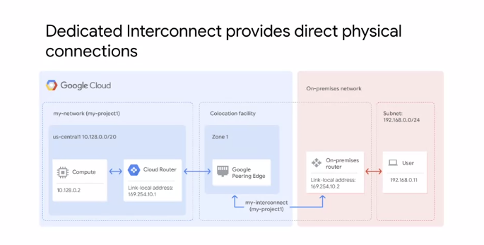

In order to use Dedicated Interconnect, you need to provision a cross-connect between the Google network and you own router in a common co-location facility as shown in this diagram. To exchange routes between the networks, you configure a BGP session over the interconnect between the Cloud Router and the on-premises router. This will allow user traffic from the on-premises network to reach Google Cloud resources on the VPC network and vice-versa.

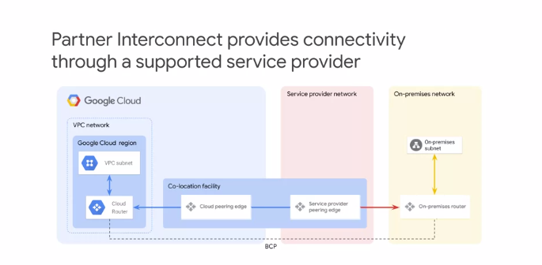

Partner Interconnect provides connectivity between your on-premises network and you VPC network through a supported service provider. This is useful if your datacenter is in a physical location that cannot reach a Dedicated Interconnect co-location facility, or if your data needs don't warrant a Dedicated Interconnect.

**Google Cloud Infrastructure as a Service**

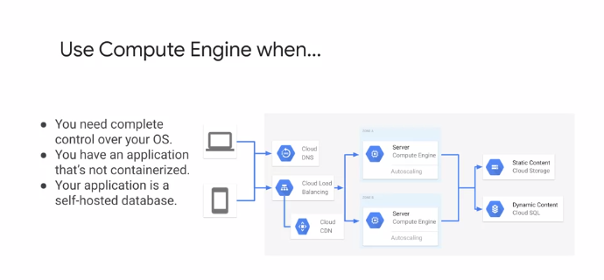

Let's begin by talking about Compute Engine, which is Google cloud's infrastructure as a service or IaaS offering. Compute Engine is a great solution when you need complete control over your operating systems, or if you have an application that is not containerized, an application built on a micro service architecture or an application that is a database. Instance groups and auto-scaling as shown on this slide allow you to meet variations in demand on your application. Let's take a closer look at instance groups.

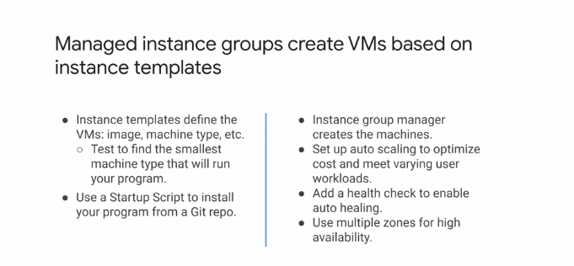

Managed instance groups create VMs based on instance templates. Instance templates are just a resource used to define VMs and manage instance groups. The templates define the boot disk image or container image to be used, the machine type labels and other instance properties like a startup script to install software from a GIT repository. The virtual machines in a managed instance group are created by an instance group manager. Using a managed instance group offers many advantages such as auto healing to recreate instances that don't respond and creating instances in multiple zones for high availability.

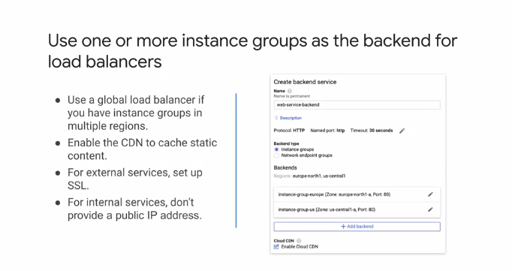

I recommend using one or more instance groups as the backend for load balancers. If you need instance groups in multiple regions, use a global load balancer. And if you have static content, simply enable Cloud CDN as shown on the right.

**Google Cloud Deployment Platforms**

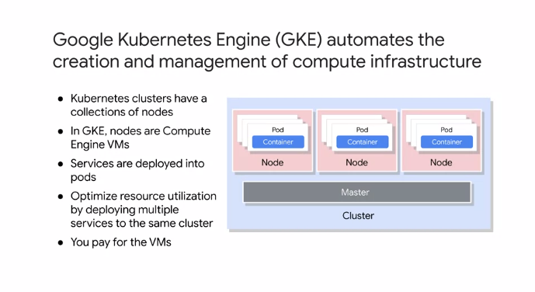

Let's go through the other deployment platforms, GKE, Cloud Run, App Engine, and Cloud Functions. Google Kubernetes Engine or GKE, provides a managed environment for deploying, managing, and scaling containerized applications using Google infrastructure. The GKE environment consist of multiple Compute Engine virtual machines grouped together to form a cluster. GKE clusters are powered by the Kubernetes open-source cluster management system. Kubernetes provides the mechanisms with which to interact with the cluster. Kubernetes commands and resources are used to deploy and manage applications, perform administration tasks and set policies, and monitor the health of deployed workloads. The diagram on the right shows the layout of Kubernetes cluster. A cluster consists of at least one cluster master and multiple worker machines that are called nodes. These master and node machines run the Kubernetes cluster orchestration system. Pods are the smallest, most basic deployable objects in Kubernetes. A pod represents a single instance of a running process in a cluster. Pods contain one or more containers such as Docker containers that run the services being deployed. You can optimize resource use by deploying multiple surfaces to the same cluster.

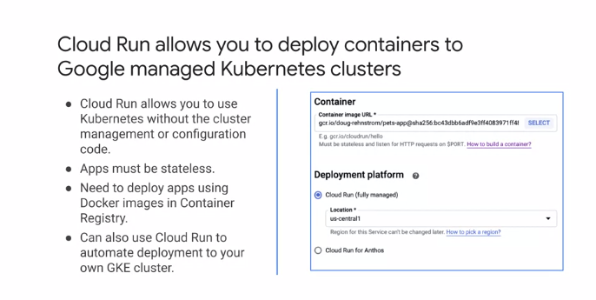

Cloud Run on the other hand, allows you to deploy containers to a Google managed Kubernetes cluster. A big advantage is that you don't need to manage or configure the cluster. The services that you deploy must be stateless and the images you use must be in Container Registry. Cloud Run can be used to automate deployment to Anthos GKE clusters. You should do this if you need more control over your services because it will allow you to access your VPC network, tune the size of compute instances, and run your services in all GKE regions. The screenshot on the right shows a Cloud Run configuration where the container image URL is specified along with the deployment platform, which can be fully managed Cloud Run or Cloud Run for Anthos.

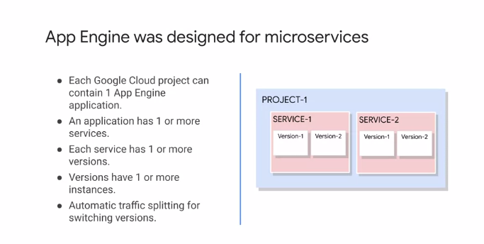

App Engine is a fully managed, serverless application platform supporting the building and deploying of applications. Applications can be scaled seamlessly from zero upward without having to worry about managing the underlying infrastructure. App Engine was designed for microservices. For configuration, each Google Cloud project can contain one App Engine application, and an application has one or more services. Each service can have one or more versions, and each version has one or more instances. App Engine supports traffic splitting, so it makes switching between versions and strategies such as canary testing or A/B testing simple. The diagram on the right shows the high level organization of a Google Cloud project with two services and each service has two versions. These services are independently deployable and versioned. Let me show you a typical App Engine microservice architecture.

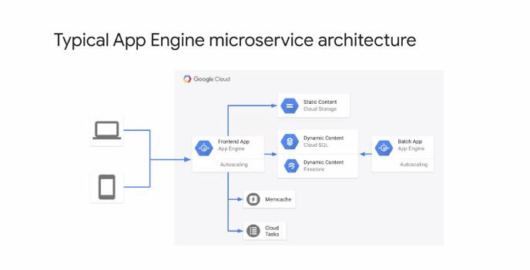

This could be an example of a retailer that sells online. Here, App Engine serves as the front end for both web and mobile clients. The back-end of this application is a variety of Google Cloud storage solutions with static content such as images stored in Cloud Storage, Cloud SQL used for structured relational data, such as customer data and sales data and Firestore used for NoSQL storage such as product data. Firestore has the benefit of being able to synchronize with client applications. Memcache is used to reduce the load on the data stores, by caching queries, and Cloud Tasks are used to perform work asynchronously outside a user request or service to service request. There's also a batch application that generates data reports for management.

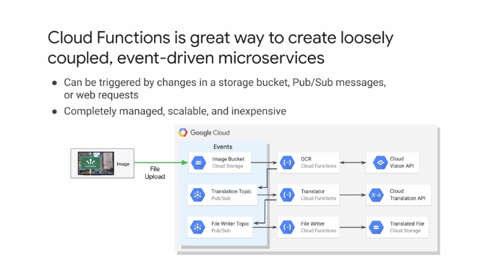

Cloud Functions are a great way to deploy loosely coupled event-driven microservices. They have been designed for processing events that occur in Google Cloud. The functions can be triggered by changes in a Cloud Storage bucket, a Pub/Sub message, or HTTP requests. The platform is completely managed, scalable, and inexpensive. You do not pay if there are no requests and processing is paid for by execution time in 100 millisecond increments. This graphic illustrates an image translation service implemented with Cloud Functions. When an image is uploaded to a Cloud Storage bucket, it triggers an OCR Cloud Function that identifies the text and the image using Google Cloud Vision API. Once the text has been identified, this service then publishes a message to a Pub subtopic for translation, which triggers another Cloud Function that will translate the identified text in the image using the Cloud Translation API. After that, the translator Cloud Function will publish a message to a file right topic in Pub/Sub, which triggers a Cloud function that will write the translated image to a file. This sequence illustrates a typical use case of Cloud Functions for event-based processing.

**Key Performance Metrics**

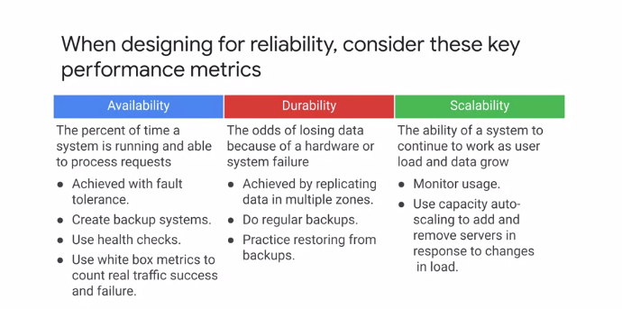

Let's start considering the key performance metrics for reliable systems. When designing for reliability, consider availability, durability, and scalability as the key performance metrics. Let me explain each of these. Availability is the percent of time a system is running and able to process requests. To achieve high availability, monitoring is vital. Health checks can detect when an application reports that it is okay. More detailed monitoring of services using white box metrics to count traffic successes and failures will help predict problems. Building in fault tolerance by for example, removing single points of failure is also vital for improving availability. Backup systems also play a key role in improving availability. Durability is the chance of losing data because hardware or system failure. Ensuring that data is preserved and available is a mixture of replication and backup. Data can be replicated in multiple zones. Regular restore is from backup should be performed to confirm that the process works as expected. Scalability is the ability of a system to continue to work as user load and data grow. Monitoring and auto-scaling should be used to respond to variations and load. The metrics for scaling can be the standard metrics like CPU or memory, or you can create custom metrics like number of players on a game server.

**Designing for Reliability**

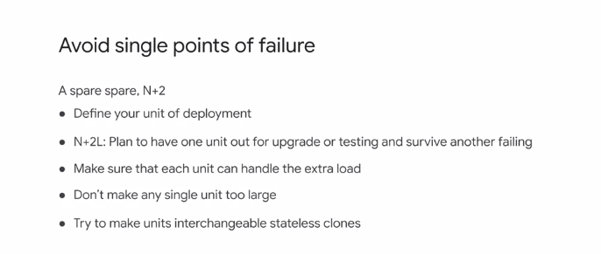

Now that we've covered the key performance metrics, let's design for reliability. Avoid single points of failure by replicating data and creating multiple Virtual Machine instances. It is important to define your unit of deployment and understand its capabilities. To avoid single points of failure, you should deploy two extra instances, or N+2 to handle both failure and upgrades. These deployments should ideally be in different zones to mitigate for zonal failures. Let me explain the upgrade consideration. Consider three VMs that are load balanced to achieve N+2. If one is being upgraded and another fails, 50 percent of the available capacity of the compute is removed, which potentially doubles alone on the remaining instance and increases the chances of that failing. This is where capacity planning and knowing the capability of your deployment unit is important. Also, for ease of scaling, it is a good practice to make the deployment units interchangeable stateless clones.

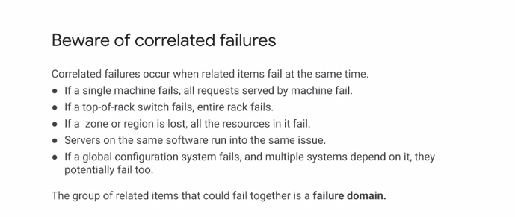

It is also important to be aware of correlated failures. These occur when related items fail at the same time. At the simplest level, if a single machine fails, all requests served by that machine fail. At a hardware level, if a top of rack switch fails, the complete rack fails. At the Cloud level, if a zone or region is lost, all the resources are unavailable. Servers running the same software suffer from the same issue. If there is a fail in the software, the servers may fail at a similar time. Correlated failures can also apply to configuration data. If a global configuration system fails and multiple systems depend on it, they potentially fail too. When we have a group of related items that could fail together, we refer to it as a failure or fault domain.

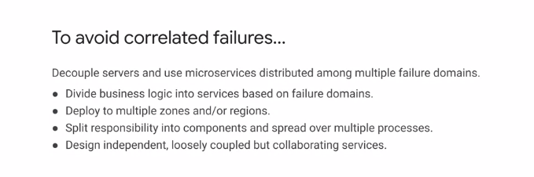

Several techniques can be used to avoid correlated failures. It is useful to be aware of failure domains. Then servers can be decoupled using microservices distributed among multiple failure domains. To achieve this, you can divide business-logic into services based on failure domains and deploy to multiple zones and, or regions. At a finer level of granularity, it is good to split responsibilities into components and spread these over multiple processes. This way, a failure in one component will not affect other components. If all responsibilities are in one component, a failure in one responsibility has a high likelihood of causing all responsibilities to fail. When you design microservices, your design should result in loosely coupled, independent but collaborating services. A failure in one service should not cause a failure in another service. It may cause a collaborating service to have reduced capacity or not be able to fully process it's workflows, but the collaborating service remains in control and does not fail.

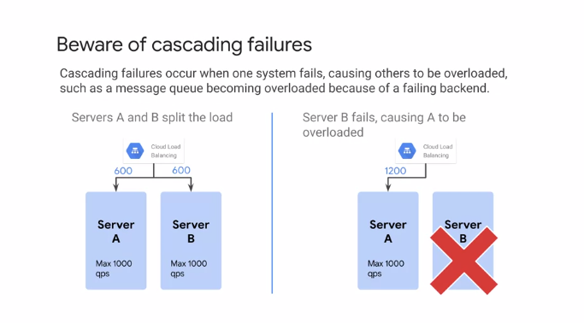

Cascading failures occur when one system fails, causing others to be overloaded and subsequently fail. For example, a message queue could be overloaded because a backend fails and it cannot process messages placed on the queue. The graphic on the left shows a Cloud Load Balancer distributing load across to backend servers. Each server can handle a maximum of 1,000 queries per second. The load balancer is currently sending 600 queries per second to each instance. If Server B now fails, all 1,200 queries per second have to be sent to just Server A as shown on the right. This is much higher than the specified maximum and could lead to cascading failure. So how do we avoid cascading failures? Cascading failures can be handled with support from the deployment platform.

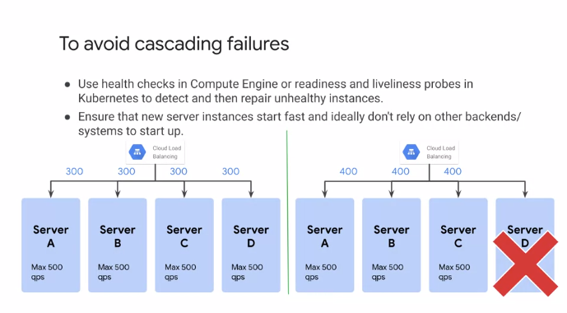

For example, you can use health checks in Compute Engine or readiness and liveliness probes and GKE to enable the detection and repair of unhealthy instances. You want to ensure that new instances start fast and ideally do not rely on other backends or systems to startup before they are ready. The graphic on this slide illustrates a deployment with four servers behind a load balancer. Based on the current traffic, a server failure can be absorbed by the remaining three servers as shown on the right-hand side. If the system uses Compute Engine with instance groups and auto healing, the failed server would be replaced with a new instance. As I just mentioned, it's important for that new server to startup quickly, to restore full capacity as quickly as possible. Also, this setup only works for stateless services.

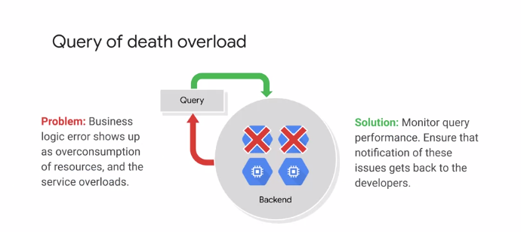

You also want to plan against query of death, where a request made to a service causes a failure in the service. This is referred to as the query of death because the error manifests itself as over consumption of resources, but in reality is due to an error in the business-logic itself. This can be difficult to diagnose and requires good monitoring, observability and logging to determine the root cause of the problem. When the requests are made, latency, resource utilization, and error rates should be monitored to help identify the problem.

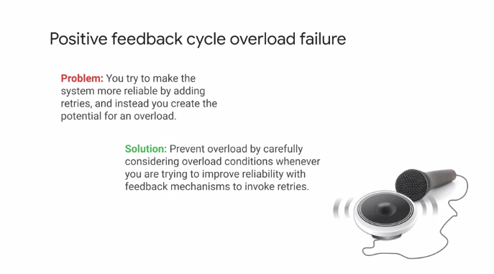

You should also plan against positive feedback cycle overload failure, where a problem is caused by trying to prevent problems. This happens when you try to make the system more reliable by adding retries in the event of a failure. Instead of fixing the failure, this creates the potential for overload. You may actually be adding more load to an already overloaded system. The solution is intelligent retries that make use of feedback from the service that is failing. Let me discuss two strategies to address this.

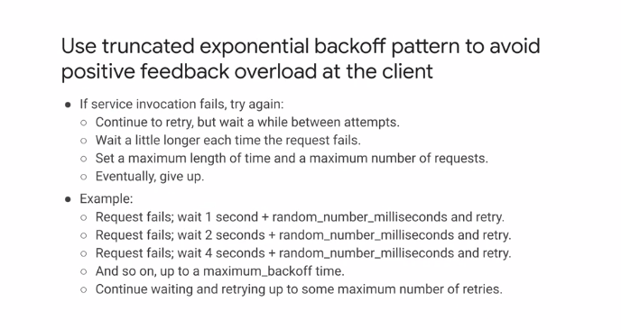

If a service fails, it is okay to try again, however, this must be done in a controlled manner. One way, to use the exponential backoff pattern. This performs a retry, but not immediately. You should wait between retry attempts, waiting a little longer each time a request fails, therefore, giving the failing service time to recover. The number of retries should be limited to a maximum, and the length of time before giving up should also be limited. As an example, consider a failed request to a service. Using exponential backoff, we may wait one second plus a random number of milliseconds and try again. If the request fails again, we wait two seconds plus a random number of milliseconds and try again. Fail again, then wait four seconds plus a random number of milliseconds before retrying and continue until a maximum limit is reached.

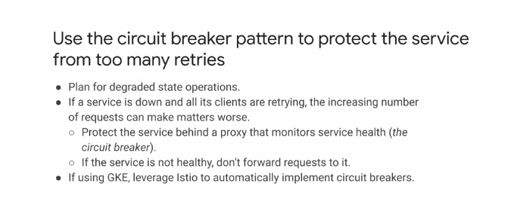

The circuit breaker pattern can also protect a service from too many retries. The pattern implements a solution for when a service is in a degraded state of operation. It is important because if a service is down or overloaded, and all it's clients are retrying, the extra requests actually make matters worse. The circuit breaker design pattern protects the service behind a proxy that monitors the service health. If the service is not deemed healthy by the circuit breaker, it will not forward request to the service. When the service becomes operational again, the circuit breaker will begin feeding request to it again in a controlled manner. If you are using GKE, the Istio's service mesh automatically implements circuit breakers.

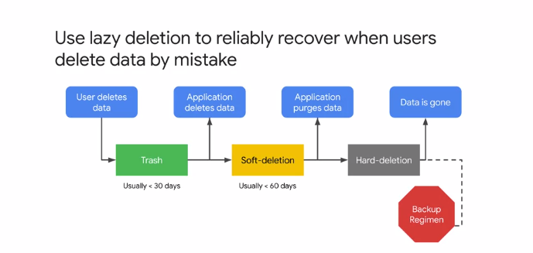

Lazy deletion is a method that builds in the ability to reliably recover data when a user deletes the data by mistake. With lazy deletion, a deletion pipelines similar to that shown in this graphic, is initiated and the deletion progresses in phases. The first stage is that the user deletes the data, but it can be restored within a predefined time period. In this example, it's 30 days. This protects against mistakes by the user. When the predefined period is over, the data is no longer visible to the user, but moves to the soft deletion phase. Here, the data can be restored by user support or administrators. This deletion protects against any mistakes in the application. After the soft deletion period of 15, 30, 45 or even 50 days, the data is deleted and no longer available. The only way to restore the data is by whatever backups or archives were made of the data.

**Disaster Planning**

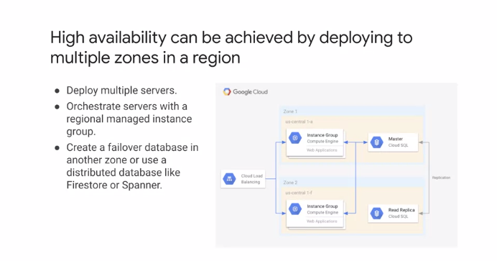

Now that we've designed for reliability, let's explore disaster planning. High availability can be achieved by deploying to multiple zones in a region. When using Compute Engine for higher availability, you can use a regional instance group, which provides built-in functionality to keep instances running. Use auto healing with an application health check and load balancing to distribute load. For data, the storage solution selected will affect what is needed to achieve high availability. For Cloud SQL, the database can be configured for high availability which provides data redundancy and a standby instance of the database server in another zone. This diagram shows a high availability configuration with a regional managed instance group for a web application that's behind a load balancer. The master Cloud SQL instance is in US central 1A with a replica instance in US central 1F. Some data services such as Firestore or Spanner provide high availability by default.

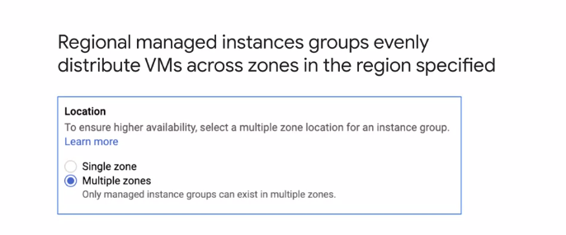

In the previous example, the original managed instance group distributes VMs across zones. You can choose between single zones, and multiple zones, or regional configurations when creating your instance group as you can see in this screenshot. Google Kubernetes Engine clusters can also be deployed to either a single or multiple zones as shown in this screenshot. A cluster consists of a master controller and collections of node pulls. Regional clusters increase the availability of both a cluster's master and it's nodes by replicating them across multiple zones of a region.

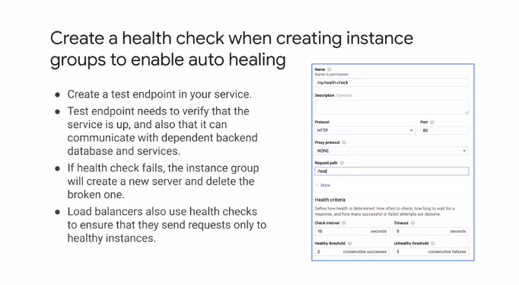

If you are using instance groups for your service, you should create a health check to enable auto healing. The health check is a test endpoint in your service. It should indicate that your service is available and ready to accept requests and not just that the server is running. A challenge with creating a good health check end point is that if you use other backend services, you need to check that they are available to provide positive confirmation that your service is ready to run. If the service says it is dependent on or not available, it should not be available. If a health check fails instance group, it will remove the failing instance and create a new one. Health checks can also be used by load balancers to determine which instances to send requests to. Let's go over how to achieve high availability for Google Cloud's data storage and database services.

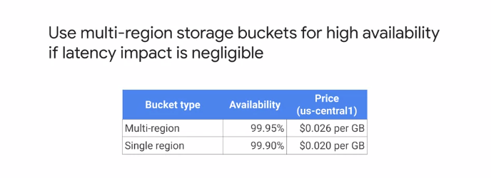

For Google Cloud Storage, you can achieve high availability with multi-region Storage buckets if the latency impact is negligible. As this table illustrates the multi-region availability benefit is a factor of two as the unavailability decreases from 0.1 percent to 0.05 percent.

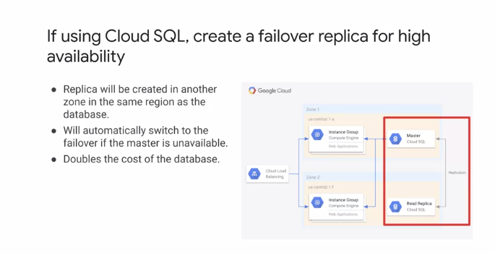

If you are using Cloud SQL and need high availability, you can create a failover replica. This graphic shows the configuration where a master is configured in one zone and a replica is created in another zone but in the same region. If the master is unavailable, the failover will automatically be switched to take over the master. Remember that you are paying for the extra instance with this design.

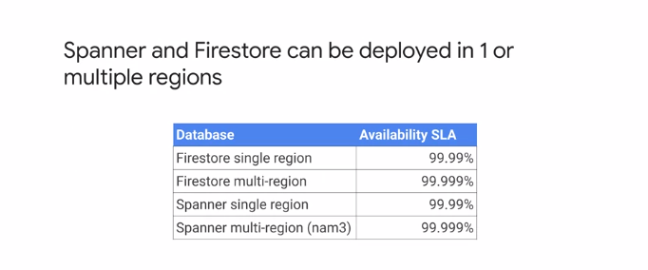

Firestore and Spanner both offer single and multi-region deployments. A multi-region location is a general geographical area such as the United States. Data and a multi-regional location is replicated in multiple regions. Within a region, data is replicated across zones. Multi-region locations can withstand the loss of entire regions and maintain availability without losing data. The multi-region configurations for both Firestore and Spanner offer five nines of availability, which is less than six minutes of downtime per year.

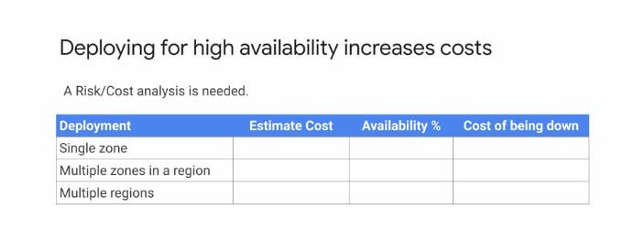

Now, I already mentioned that deploying for high availability increases costs because extra resources are used. It is important that you consider the costs of your architectural decisions as part of your design process. Don't just estimate the cost of the resources used, but also consider the cost of your service being down. This table shown is a really effective way of assessing the risk versus cost by considering the different deployment options and balancing them against the cost of being down. Now, let me introduce some disaster recovery strategies.

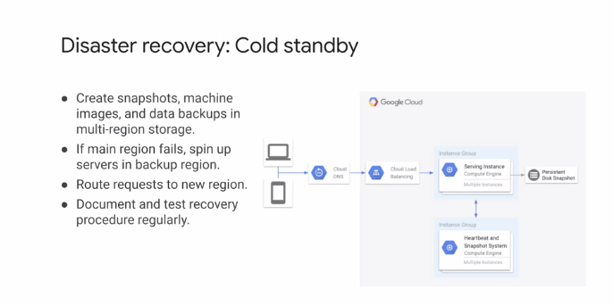

A simple disaster recovery strategy may be to have a cold standby. You should create snapshots of persistent disks, machine images, and data backups, and store them in a multi-region storage. This diagram shows a simple system using the strategy. Snapshots are taken that can be used to recreate the system. If the main region fails, you can spin up service in the backup region using the snapshot images and persistent disks. You will have to route request to the new region and it's vital to document and test this recovery procedure regularly.

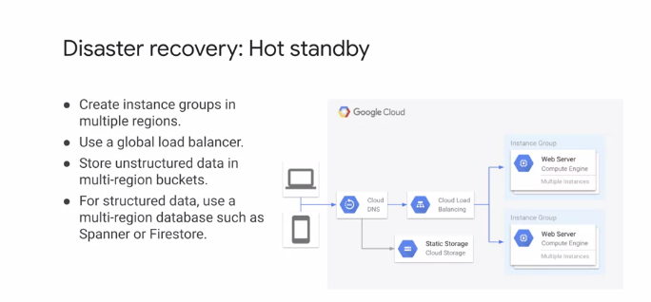

Another disaster recovery strategy is to have a hot standby where instance groups exist in multiple regions and traffic is forwarded with a global load balancer. This diagram shows such as configuration. I already mentioned this, but you can also implement this for data storage services like multi-regional Cloud Storage buckets and database services like Spanner and Firestore.

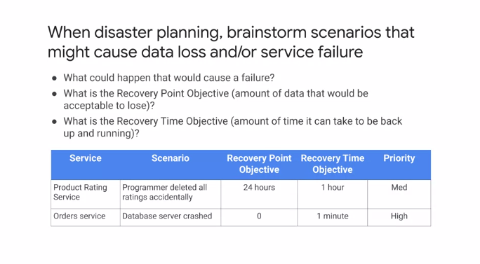

Now, any disaster recovery plan should consider its aims in terms of two metrics. The recovery point objective and the recovery time objective. The recovery point objective is the amount of data that would be acceptable to lose and the recovery time objective is how long it can take to be back up and running. You should brainstorm scenarios that might cause data loss or service failures and build a table similar to the one shown here. This can be helpful to provide structure on the different scenarios and to prioritize them accordingly. You will create a table like this in the upcoming design activity along with the recovery plan.

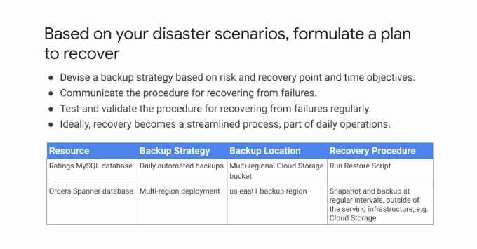

You should create a plan for how to recover based on the disaster scenarios that you define. For each scenario, devise a strategy based on the risk and recovery point and time objectives. This isn't something that you want to simply document and leave. You should communicate the process recovering from failures to all parties. The procedures should be tested and validated regularly at least once per year and ideally recovery becomes a part of daily operations, which helps streamline the process. This table illustrates the backup strategy for different resources along with the location of the backups and the recovery procedure. This simplified view illustrates the type of information that you should capture.

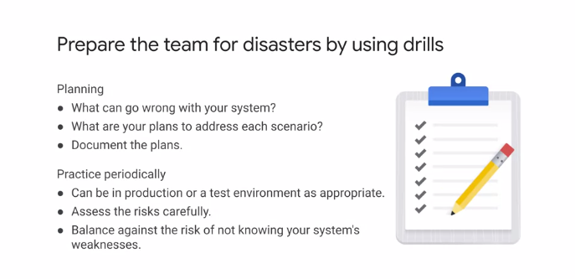

Before we get into our next design activity, I just want to emphasize how important it is to repair a team for disaster by using drills. Have you decided what you think can go wrong with your system? Think about the plans for addressing each scenario and document these plants. Then practice these plans periodically in either a test or a production environment. At each stage, assess the risks carefully and balance the costs of availability against the cost of unavailability. The cost of unavailability will help you evaluate the risk of not knowing the system's weaknesses.

**Security Concepts**

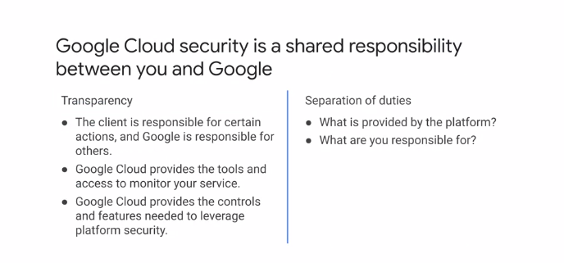

Let's begin by talking about some security concepts and introducing some of the best practices for security design. When you move an application to Google Cloud, Google handles many of the lower layers of the overall security stack. Because of its scale, Google can deliver a higher level of security at these layers than most of its customers could afford to do on their own. This does not mean that Google is responsible for all the security aspects.

Google Cloud security is a shared responsibility between you and Google. So it is important that there is a clear separation of duties, and there is no ambiguity between what is provided by the platform and what you are responsible for. For this, there needs to be transparency. There are certain actions you as a client are responsible for ,and some that Google is responsible for. Google Cloud provides the controls and features required to leverage the platform together with the tools to monitor your services.

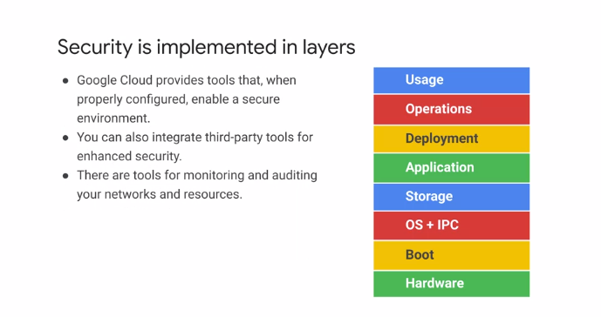

Google implements security in layers. At the base is custom built hardware and servers that are loaded using a verified boot loading system. All the way through the stack, security is at the forefront. When you take your part in security, for example, establishing firewall rules or configuring IAM, as long as they are configured correctly, you have a safe environment. There are tools Google Cloud provides that can be used for monitoring and auditing your networks, which we will discuss shortly, or you can also install your own tools.

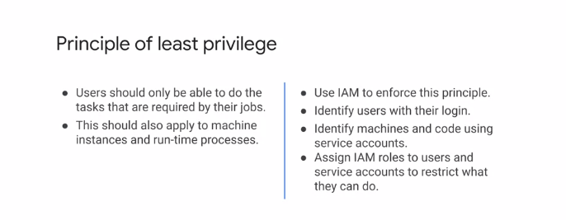

Let's talk about some best practices when implementing security. The principle of least privilege is the practice of granting a user only the minimal set of permissions required to perform a duty. This should apply to machine instances and processes, as well as users. Google Cloud provides cloud IAM to help apply this principle. You can use it to identify users with their login or identify machines using service accounts. Roles should be assigned to users and service accounts to restrict what they can do, always following the principle of least privilege.

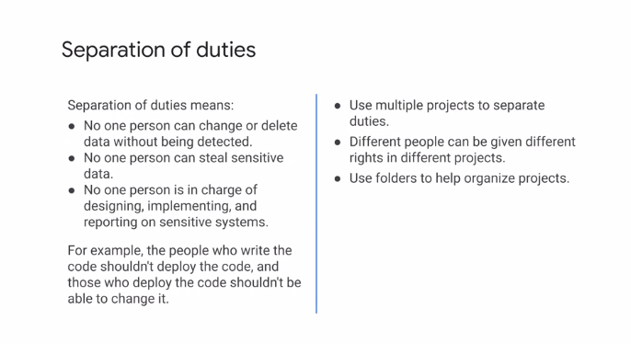

Separation of duties is another best practice and it has two primary objectives. One, prevention of conflict of interest and two, the detection of control failures. For example, security breaches and information theft. From a practical perspective, this means that no one person can change or delete data without being detected. No one person can steal sensitive data and no single person is in charge of designing, implementing, and reporting on sensitive systems. For example, a developer who writes the code should not be responsible for deploying that code, and anybody that has the permission to deploy should not be able to change the code. One approach to achieve this separation of duties in Google Cloud is to use multiple projects to separate duties. Different people can be given suitable rights to different projects, with these permissions following the principle of separation of duties. Folders are especially useful for organizing multiple projects.

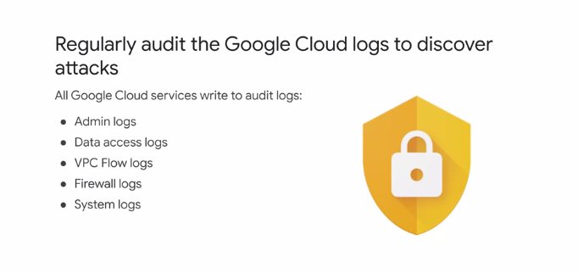

It is also vital to audit Google Cloud logs to discover attacks and potential security breaches. All Google Cloud services write to audit logs, so there is a rich source of information available. These logs include admin, data access, VPC flow, firewall, and system logs. So an in-depth view of activity is provided for audit. Now, moving to the cloud often requires maintaining compliance with regulatory requirements, or guidelines. Google Cloud meets many third party and government compliance standards worldwide.

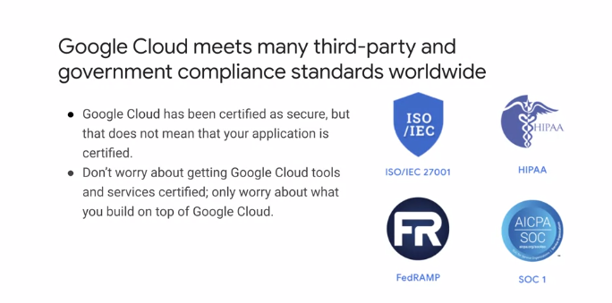

While Google cloud has been certified as secure, for example to ISO/IEC 27001, HIPAA and SOC 1, that does not mean your application running on Google Cloud is certified. Your concern should always be on what you build. Google Cloud also offers the Security Command Center, which provides access to organizational and project security configuration.

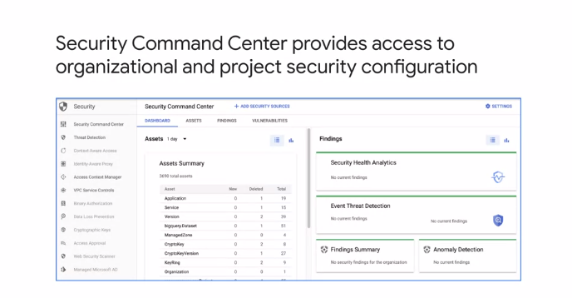

As you can see in this screenshot, the Security Command Center provides a dashboard that reports security health analysis, threat detections, anomaly detection, and a summary report. Once a threat is detected, a set of actionable recommendations is provided.

**Securing People**

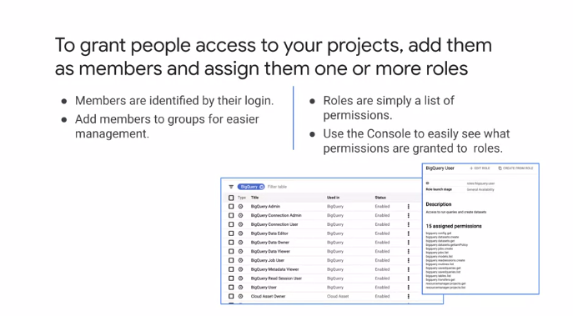

Let's move on to talk about securing people. When granting people access to your projects, you should add them as members and assign them one or more roles. Roles are simply a list of permissions. To see what permissions are granted to roles, use the Cloud Console as shown on the right. Here, you can see the role BigQuery user and the associated 15 permissions the role has assigned to it. You can assign these predefined roles to its members or customize your own roles. Now, any member added to your project will be identified by their login. For simplifying management of members and their permissions, I recommend that you create groups. That way, you just need to add members to a group and new members automatically acquire the permissions of the group. The same applies for removing members from a group, which also removes the permissions of that group.

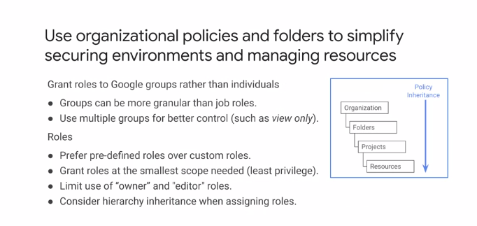

I also recommend using organizational policies and folders to simplify securing your environments and managing your resources. Organizational policies apply to all resources underneath an organization. Cloud IAM policies are also inherited top to bottom as shown on the right. Folders inherit policies of the organization, projects inherit policies of the folders, and so on. I already mentioned that roles should be granted to groups, not individuals, because it simplifies management. Make sure to define groups carefully and make them more granular than job roles. It's better to use multiple groups for better control. When it comes to roles, it's better to use predefined roles over custom roles. Google has defined the roles for a reason, and it should be an exceptional case that a role does not fit your use case. When granting roles, remember the principle of least privilege. Always grant the smallest scope required. Owner and editor roles should be limited. These are not or should not be required by the majority of users.

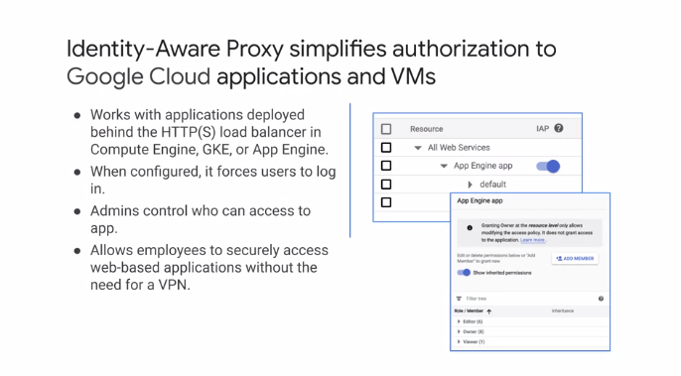

I also recommend leveraging Cloud Identity-Aware Proxy or Cloud IAP. Cloud IAP provides managed access to applications running in App Engine standard environment, App Engine flexible environment, Compute Engine, and GKE. It allows employees to securely access web-based applications deployed on Google Cloud without requiring a VPN. Administrators control who has access and users are required to log on to gain access to the applications. The screenshots on the right show Cloud IAP being enabled on an App Engine application and the dialogue for adding new members or permissions.

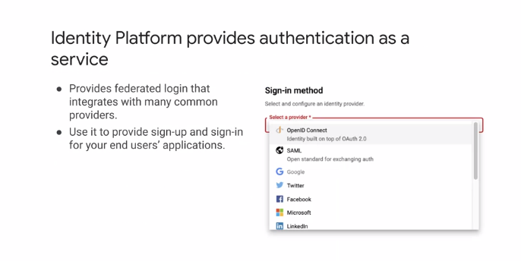

Google Cloud also offers Identity Platform as a Customer Identity and Access Management, CIAM platform for adding Identity and Access Management to applications. In other words, Identity Platform provides sign up and sign-in for end user applications. Now, you need to select a service provider to use Identity Platform. A broad range of protocol support is available, including SAML, OpenID, e-mail and password, phone, social, and Apple. This graphic shows a part of the configuration with a list of potential providers.

**Securing Machine Access**

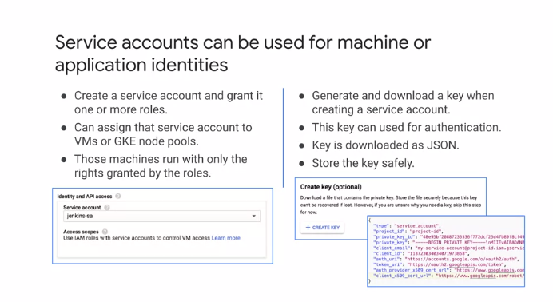

We just talked about assigning roles to members. We focused on users and Google Groups, but there's another kind of member that helps secure machine access. A service account is a special kind of account used by an application,a virtual machine, VM instance or a GKE node pool. Applications or services use service accounts to make authorized API calls. When a service account is created, it is granted one or more roles that define what resources it can be used to access. And then the VM instance, or GKE node pool, only has the rights granted by the service account. When creating a service account, you are given the option of generating a key. This is the private key for the service account. And if you download it, store the key safely. It is a JSON file that is downloaded. You will need the key to make authorized calls to Google from applications running outside Google cloud, or if you use the CLI, as we will now discuss.

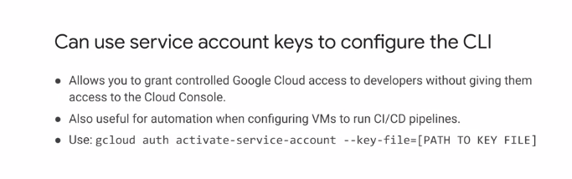

For developers to gain controlled access to resources without acquiring access to the cloud console, it is possible to configure the gcloud command line utility, to use service account credentials to make requests. The command on this slide gcloud auth activate-service-account, serves the same purpose as gcloud auth login, but uses a service account instead of user credentials. The key file contains the private key in JSON format, which I just discussed.

**Network Security**

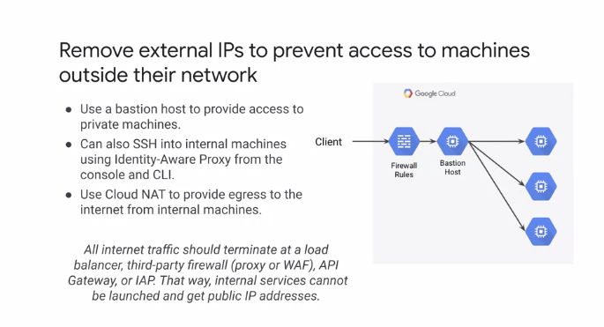

In a previous module, we talked about networks but didn't get into a lot of network security concepts. Let's do that now. First, I recommend removing external IPs to prevent access to machines from outside their network whenever possible. Several options are available for securely communicating with VMs that do not have public IP addresses. These services do not have a public IP address because they are deployed to be consumed by other instances in the project or maybe through dedicated interconnect options. However, for those instances that do not have an external IP address, it can be a requirement to gain external access, for instance, for updates or patches to be applied. The options for accessing the VMs include a bastion host for external access to private machines, Identity Aware Proxy to enable SSH access or Cloud NAT to provide egress to the internet for internal machines.

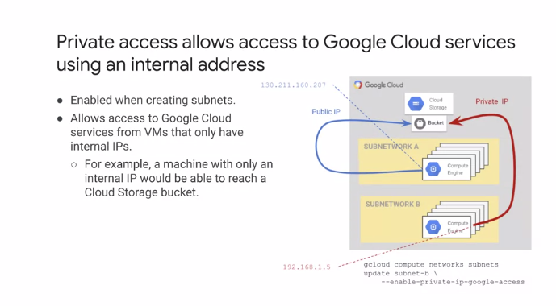

The diagram on the right shows an external client accessing Compute Engine resources via a bastion host. The host is behind a firewall where access can be filtered. Whichever method you choose, all internet traffic should terminate at a load balancer, third-party firewall, or API Gateway, or through Cloud IAP. That way, internal services cannot be launched and get public IP addresses. Now, VM instances that only have internal IP addresses can use private Google access to access Google services that have external IP addresses. The diagram on the right shows the Compute Engine instance accessing a Cloud Storage bucket using its internal IP address. Private Google access must be enabled when creating the subnet. You can achieve this either with the gcloud commands shown here or through the Cloud Console.

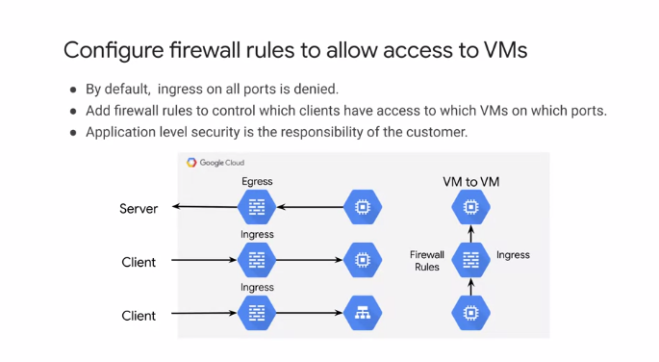

Regardless of whether your VM instances have public IP addresses, you should always configure firewall rules to control access. By default, ingress on all ports is denied and all egress is allowed. It's your responsibility to define separate rules to allow or deny access to specific instances for specific IP ranges, protocols, and ports. This graphic shows some scenarios where firewall rules can be configured. Egress from Compute Engine to external servers is the first scenario. For ingress, firewall rules should be configured if directs access to an instance is being provided or if via a load balancer. The right-hand graphic shows the scenario of VM instance to instance communication. Firewall rules should be considered here to control access also. Remember, you're still responsible for application-level security.

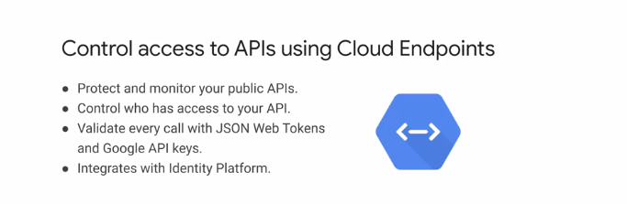

If you need to manage APIs, you can use Cloud Endpoints. Endpoints is an API management gateway that helps you develop, deploy, and manage APIs on any Google Cloud backend. It provides functionality to protect and monitored your public APIs, control who has access using, for example, auth zero, and validate every call with a JSON web tokens signed with the service account private key. Cloud Endpoints also integrates with Identity Platform for authentication.

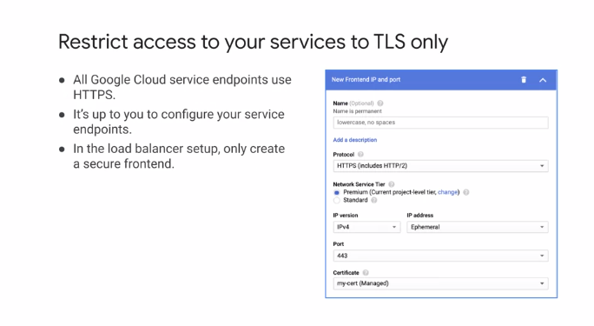

All Google Cloud service endpoints use HTTPS. I recommend that you use TLS for your service endpoints and it is your responsibility to configure your service endpoints for TLS. When configuring load balancers, only ever create secure front ends.

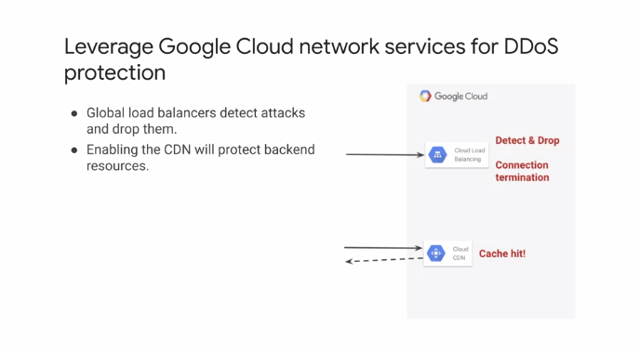

This dialog shows the configuration of a frontend and the protocol selected is HTTPS, with the certificate also being selected. Google provides Infrastructure DDoS support through global load balancers at Level 3 and Level 4 traffic. If you have enabled CDN, this will also protect back-end resources because a DDoS results in a cache hit instead of hitting your resources as shown on the right.

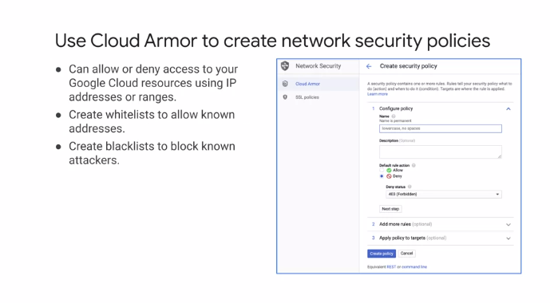

We already mentioned Google Cloud Armor in the networking module. For additional features over the built-in DDoS protection, you can use Google Cloud Armor to create network security policies. For example, you can create whitelists that allow known or required addresses through blacklists to block known attackers. This dialog shows a typical security policy configuration where you begin by selecting it as a whitelist or blacklist with allow or deny for the rule. If it's a deny, the appropriate action in this example should be a 403 error. In addition to Layer 3 and Layer 4 security, Google Cloud Armor supports Layer 7 application rules. For example, predefined rules are provided for cross-site scripting, XSS, and SQL injection attacks.

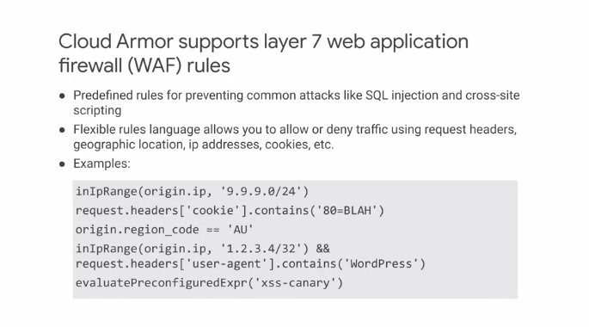

Google Cloud Armor provides a rules language for filtering request traffic. As an example, consider the first expression on this slide, inIPrange origin.IP 9.9.9.0/24. In this case, the expression returns true if the origin IP in a request is within the 9.9.9.0/24 range. The second line request.headers cookie contains 80=BLAH returns true if the cookie 80 with value BLAH exists in the request header. The third line is true if the origin region code is AU. The expressions can be combined logically with logical AND and OR. The expressions are all assigned to an allow or deny rule that is then applied to incoming traffic.

**Encryption**

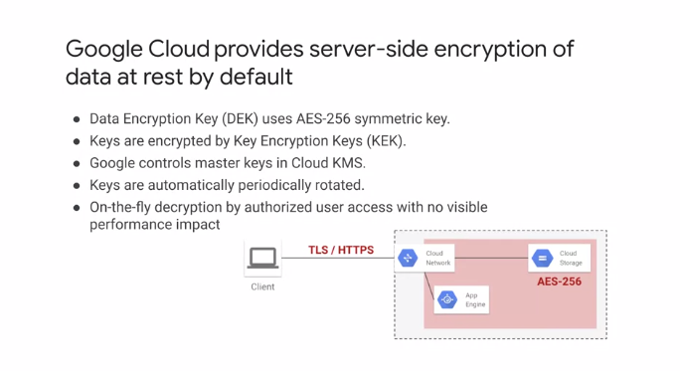

Last, but certainly not least, let's go over encryption. Google Cloud encrypts customer data stored at rest by default, with no additional action required from users. A data encryption key, or DEK, using AES-256 symmetric key, is used. And the key itself is encrypted by Google using a key encryption key, KEK. This is so that the DEK can be stored local to the encrypted data for fast decryption, with no visible performance impact to the user. To protect the KEKs, they are stored in Cloud KMS. The keys are rotated periodically and automatically for added security. This diagram shows a simple app engine application that uses Cloud Storage. The data is encrypted using AES-256, using a DEK, and decrypted transparently to the application where the data is read.

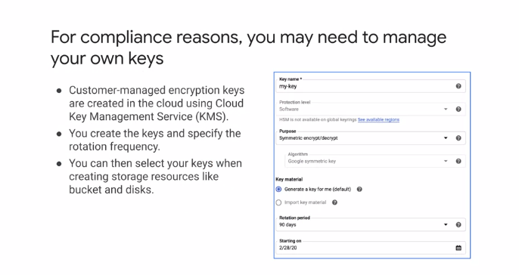

Now, for compliance reasons, you may need to manage your own encryption keys rather than the automatically generated keys, as just discussed. In this scenario, you can use Cloud Key Management Service, or Cloud KMS, to generate what are known as customer-managed encryption keys, CMEK. These keys are stored in Cloud KMS for direct use by cloud services. You can manually create the key using a dialogue similar to the one shown here and specify the rotation frequency, which defaults to 90 days. The keys you create can then be used when creating storage resources, such as disks or buckets.

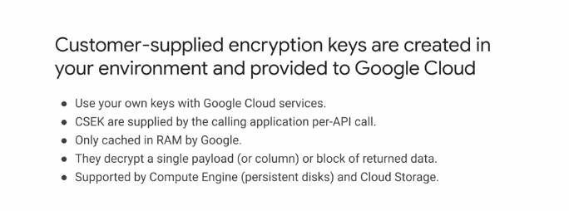

When you're required to generate your own encryption key or manage it on-premises, Google Cloud supports customer-supplied encryption keys, CSEK. Those keys are kept on-premises and not in Google Cloud. The keys are provided as part of API service calls, and Google only keeps the key in memory and uses it to decrypt a single payload or block of returned data. Currently, customer-supplied encryption keys can be used with Cloud Storage and Compute Engine.

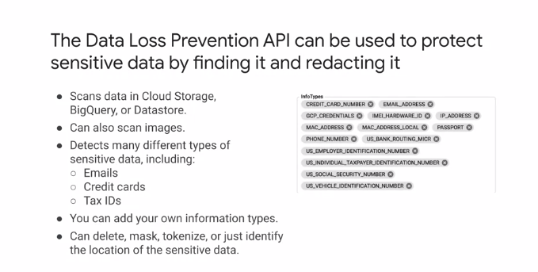

You should also consider the Data Loss Prevention API to protect sensitive data by finding it and redacting it. Cloud DLP provides fast, scalable classification and redaction for sensitive data elements, like credit card numbers, names, Social Security numbers, US and selected international identifier numbers, phone numbers, and Google Cloud credentials. Cloud DLP classifies this data using more than 90 predefined detectors to identify patterns, formats, and check sums, and even understands contextual clues. Some of these are shown on the right. You can optionally redact data as well, using techniques like masking, secure hashing, tokenization, bucketing, and format-preserving encryption.

**Managing Versions**

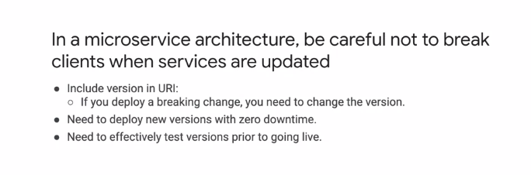

Let's begin by taking a look at version management. A key benefit of a microservice architecture is the ability to independently deploy microservices. This means that the service API has to be protected. Versioning is required and when new versions are deployed, care must be taken to ensure backward compatibility with a previous version. Some simple design rules can help, such as indicating the version in the URI and making sure you change the version when you make a backward incompatible change. Deploying new versions of software always carries risk. We want to make sure we test new versions effectively before going live and when ready to deploy a new version, we do so with zero downtime. Let me discuss some strategies that can help achieve these objectives.

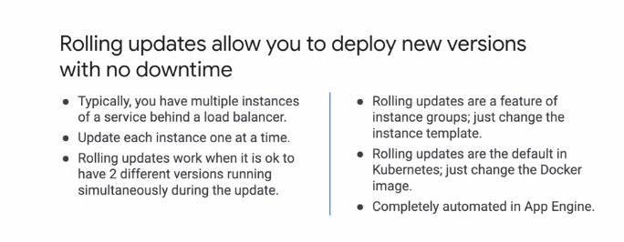

Rolling updates allow you to deploy new versions with no downtime. The typical configuration is to have multiple instances of a service behind a load balancer. A rolling update will then update one instance at a time. This strategy works fine if the API is not changed or is backward compatible or if it is okay to have two versions of the same servers running during the update. If you are using instance groups, rolling updates are a built-in feature. You just define the rolling update strategy when you perform the update.

For Kubernetes, rolling updates are there by default. You just need to specify the replacement Docker image. Finally, for App Engine, rolling updates are completely automated.

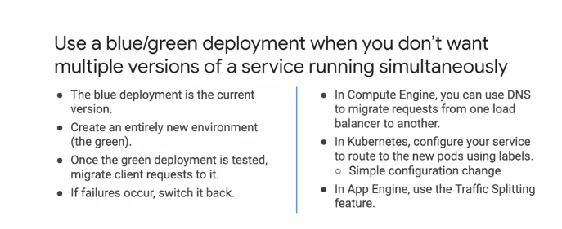

Use a blue/green deployment when you don't want multiple versions of a service to run simultaneously. Blue/green deployments use two full deployment environments. The blue deployment is running the current deployed production software while the green deployment environment is available for deploying updated versions of the software. When you want to test a new software version, you deploy to the green environment. Once testing is complete, the workload is shifted from the current, which would be the blue in this case to the new, the green environment. This strategy mitigates the risk of a bad deployment by allowing the switch back to the previous deployment if something goes wrong. For Compute Engine, you can use DNS to migrate requests while in Kubernetes, you can configure your service to route to new pods using labels, which is just a simple configuration change. App Engine allows you to split traffic which you explored in the previous lab of this course.

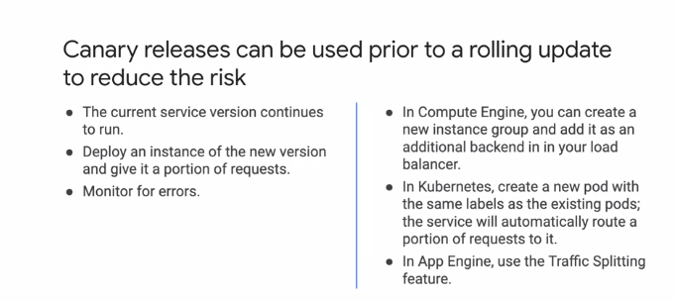

Now, you can use canary releases prior to a rolling update to reduce risk. With a canary release, you make a new deployment with the current deployment still running. Then you sent a small percentage of traffic to the new deployment and monitor it.

Once you have confidence in your new deployment, you can route more traffic to the new deployment until 100% is routed this way.

In Compute Engine, you can create a new instance group and add it to the load balancer as an additional backend. In Kubernetes, you can create a new pod with the same labels as the existing pods. The service will automatically divert a portion of the request to the new pod.

In App Engine, you can again use the Traffic Splitting feature to drive a portion of traffic to the new version.

**Cost Planning**

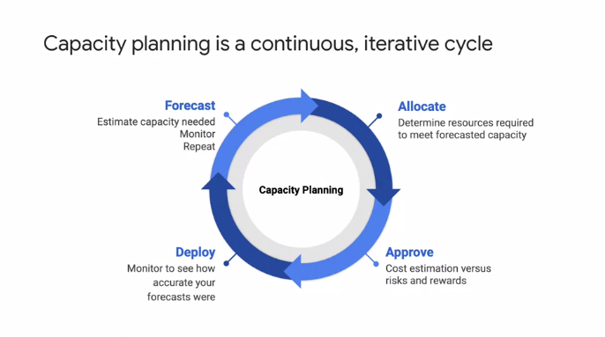

Cost planning is an important phase in your design, that starts with capacity planning. I recommend that you treat capacity planning not as a one-off task, but as a continuous iterative cycle, as illustrated on this slide. Start with a forecast that estimates the capacity needed. Monitor and review this forecast, then allocate by determining the resources required to meet the forecasted capacity. This allows you to estimate costs, and balance them against risks and rewards. Once the design and cost is approved, deploy your design and monitor it to see how accurate your forecast were. This fits into the next forecast as the process repeats. A good starting point for anybody working on cost optimization is to become familiar with the VM instance pricing.

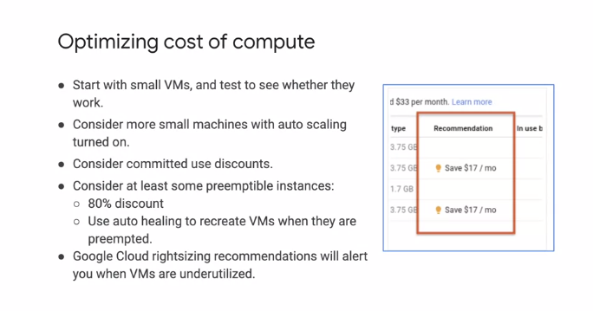

It is often beneficial to start with a couple of small machines that can scale out through auto scaling as demand grows. To optimize the cost of your virtual machines, consider using committed use discounts, as these can be significant. Also, if your workloads allow for preemptible instances, you can save up to 80 percent and use auto healing to recover when instances are preempted. Compute engine also provides sizing recommendations for your VM instances, as shown on the right. This is a really useful feature that can help you select the right size of VM for your workloads, and optimize costs. A common mistake is to over-allocate disk space.

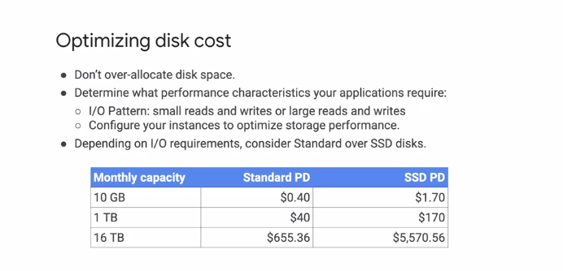

This is not cost efficient. But selecting a disk is not just about size. It is important to determine the performance characteristics your applications display. The I/O patterns, do you have large reads, small writes, vice versa, mainly read-only data? This type of information will help you select the correct type of disk. As the table shows, SSD persistent disks are significantly more expensive than standard persistent disks. Understanding your I/O patterns can help provide significant savings.

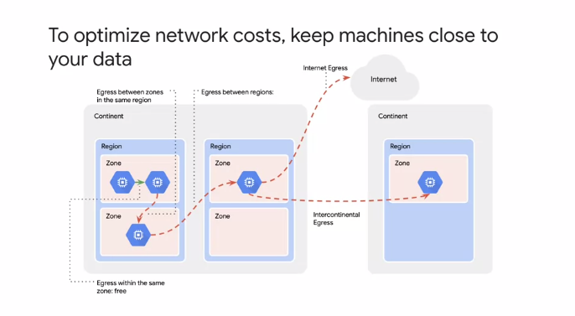

To optimize network costs, it is best practice to keep machines as close as possible to the data they need to access. This graphic shows the different types of egress within the same zone, between zones in the same region, intercontinental egress, and Internet egress. It is also important to be aware of egress charges. These are not all straightforward. Egress in the same zone is free. Egress to different Google Cloud servers within the same region using an external IP address or an internal IP address is free, except for some services such as Memorystore for Redis. Egress between zones in the same region is charged, and all Internet egress is charged. One way to optimize your network cost is to keep your machines close to your data.

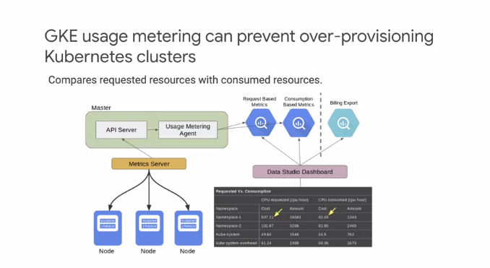

Another way to optimize cost is to leverage GKE usage metering, which can prevent over-provisioning your Kubernetes cluster. With GKE usage metering, an agent collects consumption metrics in addition to the resource requests by pulling part metric objects from the metric server. The resource requests record and resource consumption records are exported to two separate tables in BigQuery datasets that you specify. Comparing requested with consumed resources makes it easy to spot waste and take corrective measures. This graphic shows a typical configuration where BigQuery is used for request-based metrics collected from the usage metering agent, and together with data obtained from Billing Export, it is analyzed in a data studio dashboard.

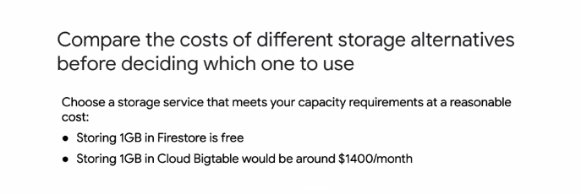

Earlier in the course, we talked about all of the different storage services. It's important to compare the costs of the different options, as well as their characteristics. For example, as of this recording, Firestore provides one gigabyte of storage for free under the free access tier. If you stored the same amount of data in Cloud Bigtable, you could pay over $1,000 per month, because you'd need at least three Bigtable nodes. In other words, your storage and database servers choice can make a significant difference to your bill.

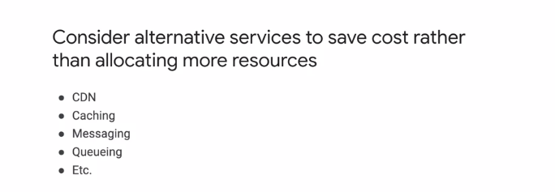

Your architectural design can also help you optimize your costs. For example, if you use Cloud CDN for static content or Memorystore as a cache, you can save instead of allocating more resources. Similarly, instead of using a data store between two applications, considering messaging and queuing with pops up to decouple communicating services, and reduce storage needs.

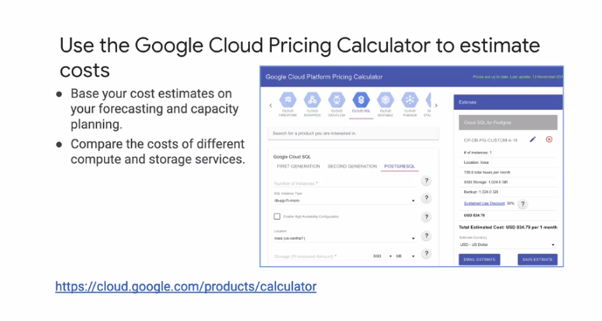

The pricing calculator should be your go-to resource for estimating costs. Your estimates should be based on your forecasting and capacity planning. The tool is great for comparing costs of different compute and storage services, and you will use it in the upcoming design activity.

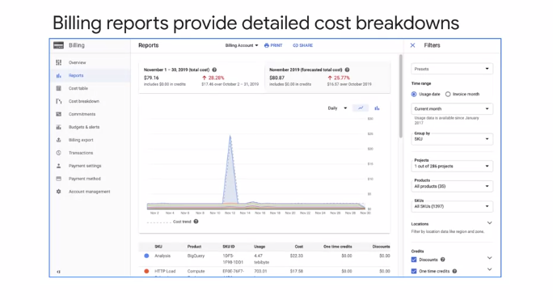

To monitor the cost of your existing service, leverage the Cloud Billing Reports page as shown here. This report shows the changes in costs compared to the previous month, and you can use the filters to search for particular projects, products, and regions as shown on the right. The sizing recommendations for your compute engine instances will also be in this report.

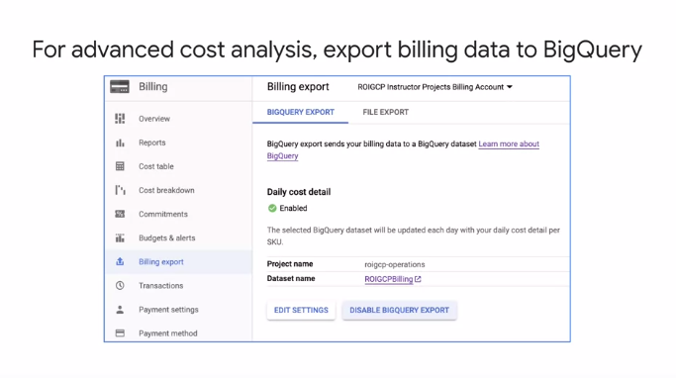

For advanced cost analysis, I recommend exporting your billing data to BigQuery, as shown in the screenshot. You can then analyze the billing data to identify large expenses and optimize your Google Cloud spend. For example, let's assume you label VM instances that are spread across different regions. Maybe these instances are sending most of their traffic to a different continent, which could incur higher costs. In that case, you might want to consider relocating some of those instances, or using a caching service like Cloud CDN to cache content closer to your users, which reduces your networking spent.

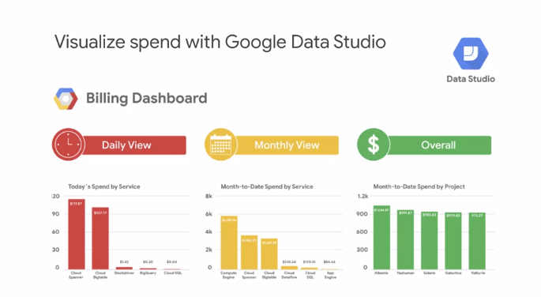

You can even visualize spend over time with Google Data Studio, which turns your data into informative dashboards and reports that are easy to read, easy to share, and fully customizable. The service data is displayed in a daily and monthly view, providing at-a-glance summaries that can also be drilled down in to provide greater insights.

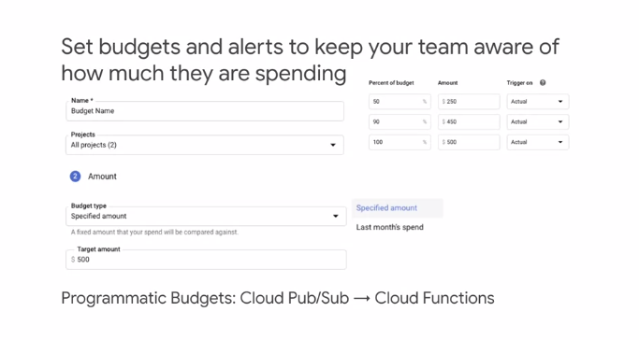

To help with project planning and controlling costs, you can set a budget. Setting a budget lets you track how your spend is growing toward that amount. This screenshot shows the budget creation interface. First, set a budget name and specify which project this budget applies to. Then set the budget at a specific amount or match it to the previous month spent. Last, set the budget alerts. These alerts send e-mails to billing admins after spend exceeds a percent of a budget or a specified amount. In our case, it would send an e-mail when spending reaches 50, 90, and 100 percent of the budget amount. You can even choose to send an alert when the spend is forecasted to exceed the percent of the budget amount by the end of the budget period. In addition to receiving an e-mail, you can use Pub/Sub Notifications to programmatically receive spend updates about this budget. You could even create a Cloud Function that listens to the Pub/Sub topic to automate cost management

**Monitoring Dashboards**

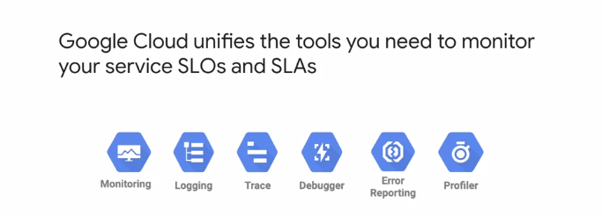

Let's get into monitoring and visualizing information with dashboards. Google Cloud unifies the tools you need to monitor your service, SLOs and SLAs in real-time. These tools include Monitoring, Logging, Trace, Debugger, Error Reporting, and Profiler. All of these enable you to gain the insights you need to achieve your SLOs and determine the root cause in those rare cases that you do not achieve your SLOs.

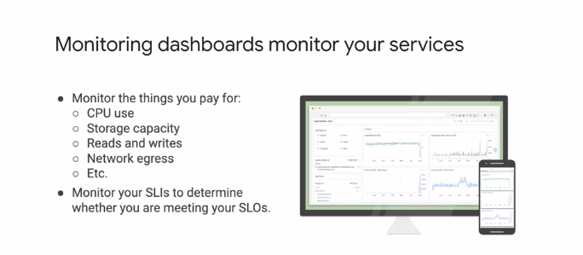

Dashboards are one way for you to view and analyze metric data that is important to you. This includes your SLIs to ensure that you are meeting your SLAs. The monitoring page of the Cloud Console automatically provides predefined dashboards for the resources and services that you use. It is important that you monitor these things you pay for to determine the trends, bottlenecks, and potential cost savings.

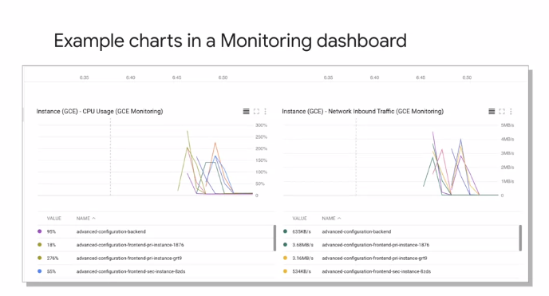

Here's an example of some charts in a monitoring dashboard. On the left, you can see the CPU usage for different compute engine instances, and on the right is the ingress traffic for those instances. Charts like these provide valuable insights into usage patterns.

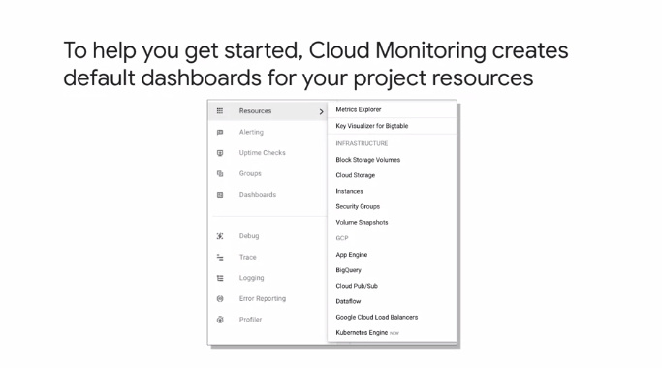

To help you get started, Cloud monitoring creates default dashboards for your project resources, as shown in this screenshot. You can also create custom dashboards which you can explore in the upcoming lab.

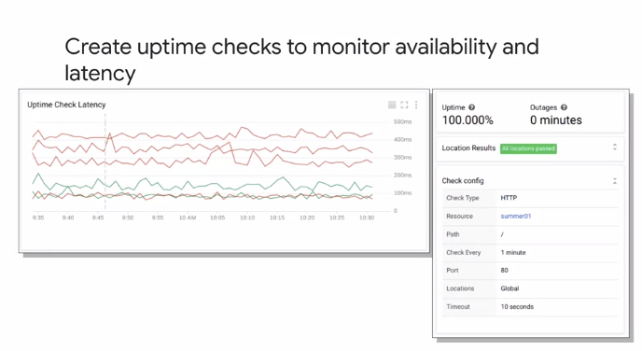

Now, it's a good idea to monitor latency because it can quickly highlight when problems are about to occur. As shown on the slide, you can easily create uptime checks to monitor the availability and latency of your services. So far, there is a 100 percent uptime with no outages. Latency is actually one of the four golden signals called out in Google's Site Reliability Engineering, or SRE book. SRE is a discipline that applies aspects of software engineering to operations whose goals are to create ultra scalable and highly reliable software systems. This discipline has enabled Google to build, deploy, monitor, and maintain some of the larger software systems in the world. I've linked the SRE book and the slides of this module.

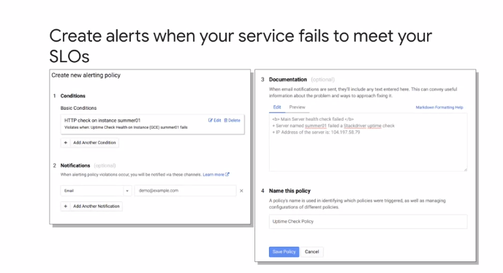

Your SLO will be more strict than your SLA. So it is important to be alerted when you are not meeting an SLO because it's an early warning that the SLA is under a threat. Here's an example of what creating an alerting policy looks like. On the left, you can see an HTTP check condition on the summer01 instance. This will send an e-mail that is customized with the content of the documentation section on the right.